Torres Strait Tropical Rock Lobster Catch Data Summary
Table 1. Torres Strait Tropical Rock Lobster Fishery catch and total allowable catch for the years 2012 to 2016.
Year | TIB Catch (t) | TVH Catch (t) | PNG Catch (t) | Total Catch (t) | Global TAC (t) | Catch as % of TAC
2012 | 152.9 | 370.5 | 173.7 | 697.0 | 964 | 72%
2013 | 134.2 | 361.7 | 108.3 | 604.2 | 871 | 69%
2014 | 148.5 | 272.7 | 151.4 | 682.4 | 616 | 111%
2015 | 173.9 | 152.7 | 235.7 | 562.3 | 769 | 73%
2016 | 207.1 | 237.6 | 127.1 | 571.8 | 796 | 72%
*Catch is whole weight
Number of active vessels 2016
- Number of active TIB’s (primary and tenders) 2016: No vessel symbols recorded in Docketbook, though 170 distinct Seller Names
- Number of active TVH (primary and tenders) 2016: 12 primary vessels, 30 tenders
Table 2. Torres Strait Tropical Rock Lobster Fishery TIB sector catch by zone for 2016 (refer to map of TIB zones below).
TIB  Area | Area Name | TIB Catch (Kgs) | TIB  Area | Area Name | TIB Catch (Kgs)
0 | Unknown | 127,923 | 11 | Warrior | 753
1 | Turu Cay | 13 | 12 | Warraber | 2,807
2 | Deliverance Island | 0 | 13 | Mt Adolphos | 09
3 | Northern Section | 0 | 14 | Great NE Channel | 0
4 | Bramble Cay | 0 | 15 | South East | 0
5 | Anchor Cay | 72 | 16 | Darnley | 55
6 | Western | 99 | 17 | Cumberland | 0
7 | Mabuiag | 1,411 | 18 | Seven Reefs | 0
8 | Badu | 24,806 | 19 | Don Cay | 0
9 | Thursday Island | 48,982 | 20 | Barrier | 0
10 | Central | 98 | 21 | GBR | 54

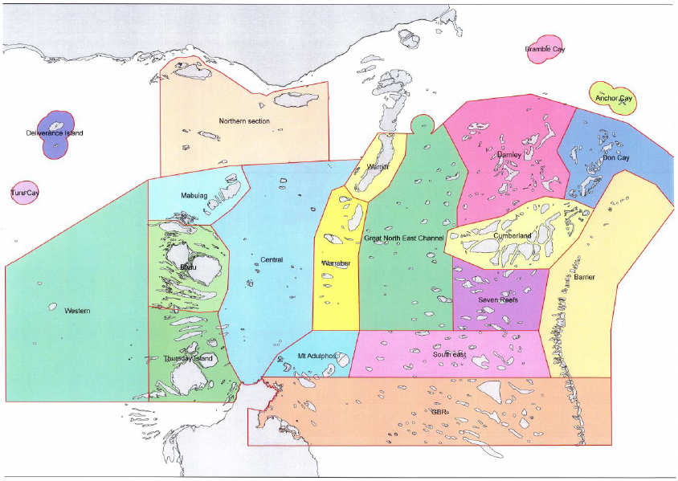
Table 3. Torres Strait Tropical Rock Lobster Fishery TVH sector catch by zone for 2016 (refer to map of TVH zones below).
TVH  Area | Area Name | TVH Catch (Kgs) | TVH  Area | Area Name | TVH Catch (Kgs)
0 | Unknown | 831 | 10 | Northern section | 4,071
1 | Badu | 8,141 | 11 | Seven Reefs | 0
2 |  |  | 12 | South East | 0
3 | Central | 25,182 | 13 | Thursday Island | 585
4 | Cumberland | 1,866 | 14 | Warraber | 35,732
5 | Darnley | 0 | 15 | Warrior | 53,936
6 | Don Cay | 146 | 16 | Western | 0
7 | Great NE Channel | 14,429 | 17 | Kirkaldie | 90,161
8 | Mabuiag | 955 | 18 | PNG | 0
9 | Mt Adolphos | 1,579 | 19 | GBR | 0

