COMMUNITY SUMMARY
Torres Strait Tropical Rock Lobster (TRL) Fishery
Science and management
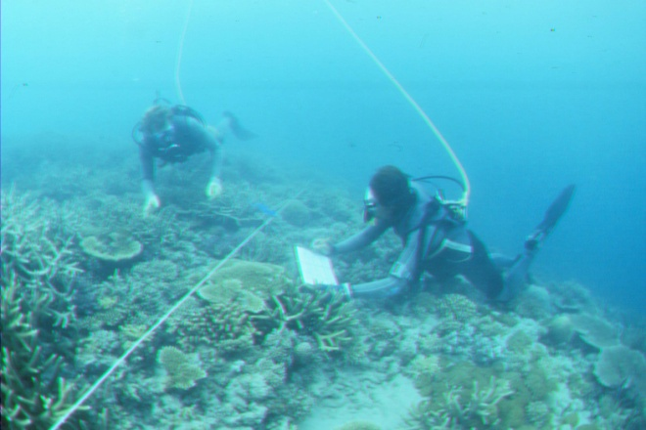
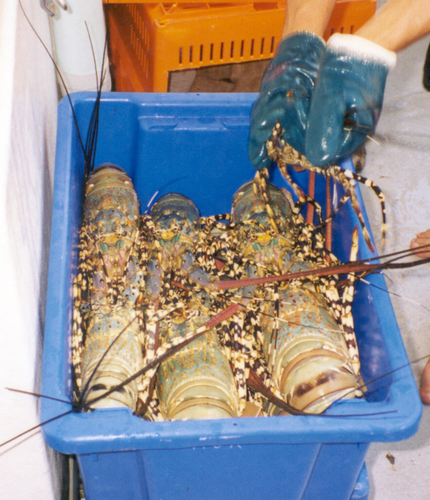
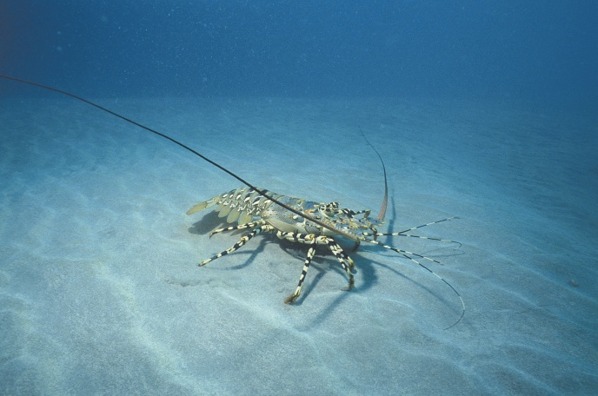
CSIRO/AFMA
March 2017
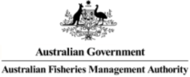
Éva Plagányi, Darren Dennis, Roy Deng, Robert Campbell, Trevor Hutton, Mark Tonks, Mick Haywood

Community Summary: Proposed Harvest Strategy for Kaiar
We want to make sure that there will always be lots of kaiar in Torres Strait by managing the TRL fishery effectively into the future. This is because kaiar are very important economically as well as culturally. Researchers, fishers and managers together agree on what number of kaiar can be caught each year to keep the population healthy and the fishery performing well (called target reference points). They also agree on the low population numbers that cause concern and should be avoided (called limit reference points). These numbers will be very important for use in the TRL harvest strategy as described below.
As we all know kaiar numbers go up and down from one year to the next because of natural changes in the environment. In good years we can catch more, but in bad years we need to catch less. We have some good indicators that provide information on how many kaiar there are and how many should be caught.
Firstly fisher catches – if a fisher catches more kaiar each day than in most years, it means there are lots of large kaiar in the population. This also means there should be lots of kaiar left to breed and release eggs. But if there are fewer kaiar being caught each day than in most years, it means there are fewer kaiar left to breed and less should be caught.
Secondly science surveys – surveys have been run by CSIRO for the past 28 years (since 1989) to work out how many kaiar there are on the fishing grounds. The surveys are now run in November (called pre-season surveys) because this is close to the start of the fishing season. If there are lots of kaiar counted on the survey, there should be good numbers in the fishery and it is safe to catch lots of kaiar. If few kaiar are counted, it means that the next year will be a bad year for kaiar and catches should be smaller.
If the fishery catch was set at the same number each year (fixed), then we would have to make sure that the catch wasn’t too high in a bad year. This means a fixed total catch would need to be very small. A better strategy is to change the total catch that is allowed every year up or down depending on the actual number of kaiar available. This is possible because of the information we have from fisher catches and science surveys.
At the moment we use a complex computer model with the catch and survey information to work out how many kaiar can be caught. However, we can also work these numbers out using a Harvest Control Rule (HCR), which is much simpler and takes less time to calculate. Scientific testing suggests that a HCR should work well for the kaiar fishery into the future.
Researchers, fishers and managers also agreed to some extra rules to use with the HCR. Because the fishery is so important the largest catch that would be allowed is 1000 t. Very low survey numbers would be worrying and it was agreed that the computer model would be used in these years to make sure the HCR is working well. It was also agreed that the computer model would be used every three years in any case; as a double check on how many kaiar we think there are in the population.
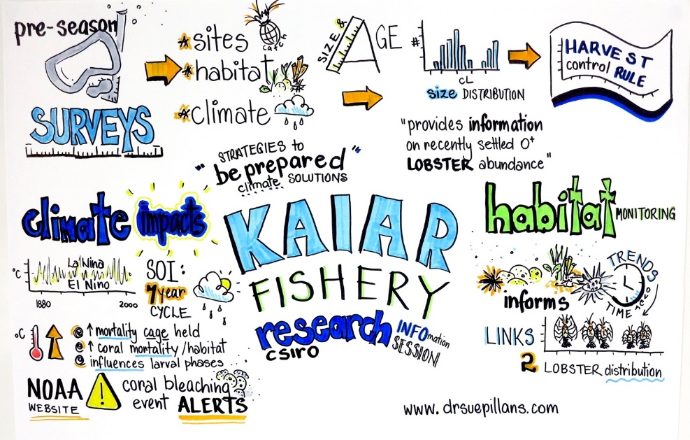
Of course it is very important for management of the fishery that good information is collected on catches and that good science surveys are done. If more information can be collected and better surveys are done, then it is possible to improve management and increase catches.
Visual story of the Kaiar Fishery CSIRO research information session held with the TRL community on Thursday Island in November 2016 explaining the fisheries science (Graphic by Dr Sue Pillans, www.drsuepillans.com)
Staff at AFMA Thursday Island and CSIRO Brisbane will be happy to answer any other questions you may have.

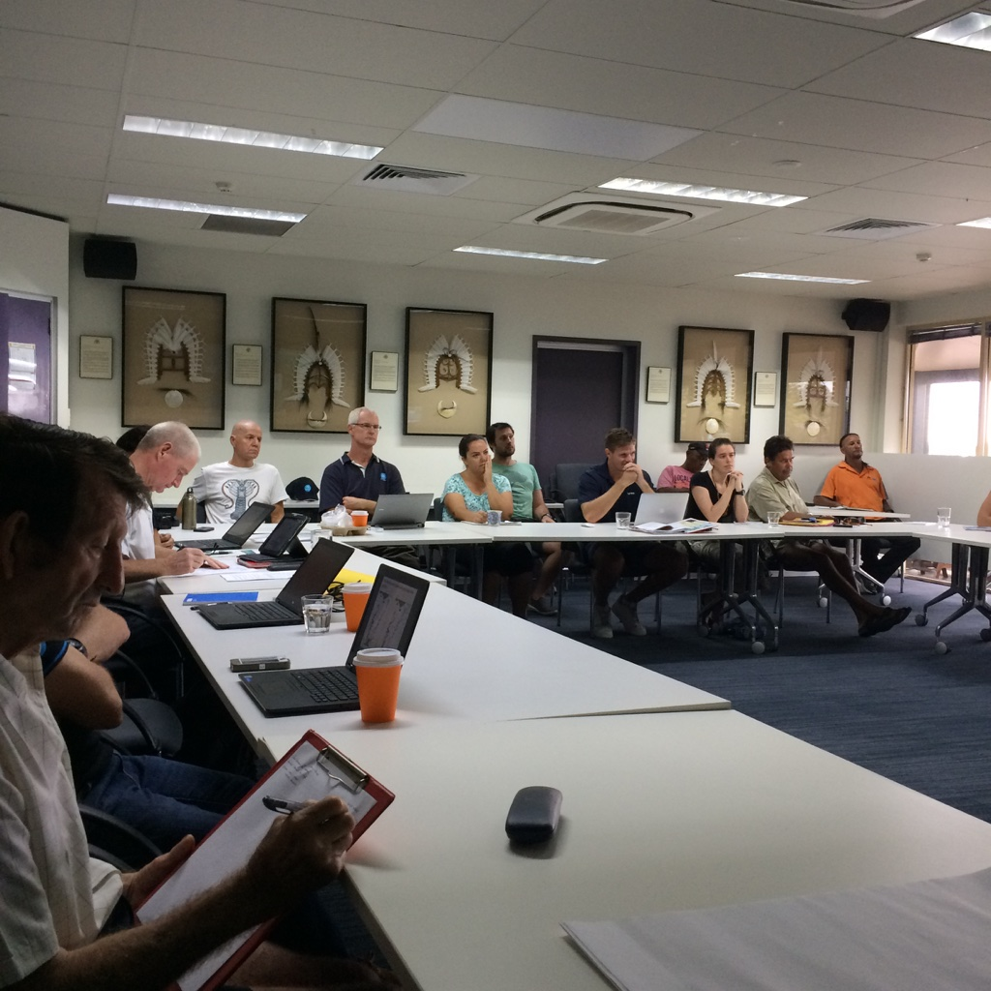
CSIRO engaging with the Torres Strait TRL community to discuss the science of the Kaiar Fishery, on Thursday Island in November 2016

