Torres Strait Protected Zone Joint Authority
Annual Report 2010–11
Torres Strait Fisheries Act 1984 (Commonwealth)
  - PROTECTED ZONE JOINT AUTHORITY
Annual Report 2010–11
  - ANNUAL REPORT
1 JULY 2010 TO 30 JUNE 2011
PRESENTED TO PARLIAMENT PURSUANT TO SECTION 41 OF THE ACT

Senator the Hon. Richard Colbeck
Parliamentary Secretary to the Commonwealth Minister for Agriculture.
Chair of the Protected Zone Joint Authority
Parliament House
CANBERRA ACT 2600
The Hon. John McVeigh, MP
Queensland Minister for Agriculture, Fisheries and Forestry.
Member of the Protected Zone Joint Authority
Parliament House
BRISBANE QLD 4000
Mr Joseph Elu
Chair of the Torres Strait Regional Authority
Member of the Protected Zone Joint Authority
PO Box 261
THURSDAY ISLAND
QLD 4875

© Commonwealth of Australia 2014
This work is copyright. Apart from any use as permitted under the Copyright Act 1968, no part may be reproduced by any process without prior written permission from the Commonwealth. Requests and inquiries concerning reproduction and rights should be addressed to the Commonwealth Copyright Administration, Attorney-General’s Department, Robert Garran Offices, National Circuit, Barton ACT 2600 or posted at: www.ag.gov.au/cca.
ISSN 0819-1050 (Print)
ISSN 1835-7261 (Online)
PZJA annual reports are available at:
www.pzja.gov.au/resources/publications/annual-reports
Published by the Australian Fisheries Management Authority on behalf of the Protected Zone Joint Authority
Contact officer: Cate Coddington
AFMA email: info@afma.gov.au
Box 7051
Canberra Business Centre ACT 2610
ABN 81 098 497 517
Agency websites:
PZJA: www.pzja.gov.au
AFMA website: www.afma.gov.au
Fisheries Queensland: www.daff.qld.gov.au/fisheries
TSRA: www.tsra.gov.au

ACRONYMS AND ABBREVIATIONS
ABARES Australian Bureau of Agricultural and Resource Economics and Sciences
AFMA Australian Fisheries Management Authority
AQIS Australian Quarantine and Inspection Service
BAP Bycatch Action Plan
CSA Cost Sharing Arrangement
CSIRO Commonwealth Scientific and Industrial Research Organisation
DAFF Commonwealth Department of Agriculture, Fisheries and Forestry
DEEDI Queensland Department of Employment, Economic Development and Innovation
EPBC Act Commonwealth Environment Protection and Biodiversity Conservation Act 1999
F_{MSY} Fishery Maximum Sustainable Yield
GBRMPA Great Barrier Reef Marine Park Authority
MAC Management Advisory Committee
MSY Maximum Sustainable Yield
PNG Papua New Guinea
PZJA Protected Zone Joint Authority
QBFP Queensland Boating and Fisheries Patrol (a division of DEEDI)
QPI&F Queensland Primary Industries and Fisheries (a division of DEEDI)
QPS Queensland Police Service
QSIA Queensland Seafood Industry Association
RAG Resource Assessment Group
SAC Scientific Advisory Committee
SEWPaC Commonwealth Department of Sustainability, Environment, Water, Population and Communities
TAC Total Allowable Catch
TAE Total Allowable Effort
TBD To be determined
The Act The Torres Strait Fisheries Act 1984
The Treaty The Torres Strait Treaty
TIB Traditional Inhabitant Fishing Boat Licence
TRL Tropical Rock Lobster
TSBDMF Torres Strait Bêche-de-mer Fishery
TSCF Torres Strait Crab Fishery
TSD&TF Torres Strait Dugong and Turtle Fishery
TSFMAC Torres Strait Fisheries Management Advisory Committee
TSPF Torres Strait Prawn Fishery
TSPMAC Torres Strait Prawn Management Advisory Committee
TSPSF Torres Strait Pearl Shell Fishery
TSPZ Torres Strait Protected Zone
TSTRLF Torres Strait Tropical Rock Lobster Fishery
TSTF Torres Strait Trochus Fishery
TSRA Torres Strait Regional Authority
TVH Torres Strait Fishing Boat Licence
UFC Units of Fishing Capacity
WG Working Group
WTO Wildlife Trade Operation

ACKNOWLEDGMENTS
The Protected Zone Joint Authority gratefully acknowledges the late Lindsay Wilson for permission to use drawings of traditional Torres Strait artefacts and other objects in this Annual Report series from the publications “Thalilgaw emeret lu, a handbook of traditional Torres Strait Islands material culture” and “Kerkar lu: contemporary artefacts of the Torres Strait Islanders”.

CONTENTS
ACRONYMS AND ABBREVIATIONS 4
ACKNOWLEDGMENTS 5
CONTENTS 6
1 INTRODUCTION 8
2 BACKGROUND 8
The Torres Strait 8
The Torres Strait Treaty 8
The Torres Strait Fisheries Act 1984 9
3 THE PROTECTED ZONE JOINT AUTHORITY 10
Roles and responsibilities 10
Meetings 11
Consultative structure 11
4 COOPERATION WITH PAPUA NEW GUINEA 15
Catch sharing 15
Outside but near areas 15
5 FISHERIES 16
Commercial fisheries 16
Traditional fisheries 16
Article 22 fisheries 17
Non-article 22 fisheries 34
6 LICENSING 46
7 SURVEILLANCE AND ENFORCEMENT 49
Background 49
Program outcomes 50
Overall program outcomes 52
8 RESEARCH PROGRAMS 53
9 FINANCIAL ARRANGEMENTS 54
Cost sharing 54
Capital items 54
Research costs 54
Overall expenditure 55
ANNEX A: PZJA OUTCOMES 2010–11 57
ANNEX B: PZJA ADVISORY COMMITTEE AND TORRES STRAIT CONSULTATIVE STRUCTURE: MEMBERSHIP AND MEETING FREQUENCY 59
Protected Zone Joint Authority (PZJA) 59
Membership of Torres Strait consultative bodies 59
Meetings 65
ANNEX C: TORRES STRAIT FISHERIES RELATED REPORTS 2010–11 66
ANNEX D: FREEDOM OF INFORMATION ACT AND OCCUPATIONAL HEALTH AND SAFETY ACT STATEMENTS 67

1 INTRODUCTION
This, the twenty-fifth Annual Report of the Protected Zone Joint Authority (PZJA), describes PZJA activities during the year ending 30 June 2011 and the condition of the fisheries in the Torres Strait Protected Zone (TSPZ) (Figure 1). The PZJA is responsible for management of commercial and traditional fishing in the Australian area of the TSPZ and designated adjacent Torres Strait waters.

2 BACKGROUND

The Torres Strait
The Torres Strait is located between the tip of Cape York Peninsula and Papua New Guinea (PNG). It consists of over one hundred islands and reefs which have evolved from four major origins: volcanic, alluvial, coral cays and flooded land bridges which were once part of the Great Dividing Range. Geographically, the islands are divided into inner, eastern, central, western, and top-western island groups; 18 of which are currently inhabited.

The Torres Strait Treaty
Australia ratified the Torres Strait Treaty (the Treaty) on 15 February 1985. The Treaty is concerned with sovereignty and maritime boundaries in the area between Australia and PNG. The Treaty establishes the TSPZ which aims to protect the traditional way of life and livelihood of the Traditional Inhabitants of the Torres Strait and adjacent coastal areas of the two countries. Australia and PNG are obligated to cooperate in the conservation, management and utilisation of the TSPZ fisheries and both countries enjoy sovereign rights within the TSPZ. This includes the right to a share of the commercial harvest of swimming fish and sedentary species on the respective sides of the agreed fisheries and seabed jurisdiction lines (see Figure 1 on page 9).
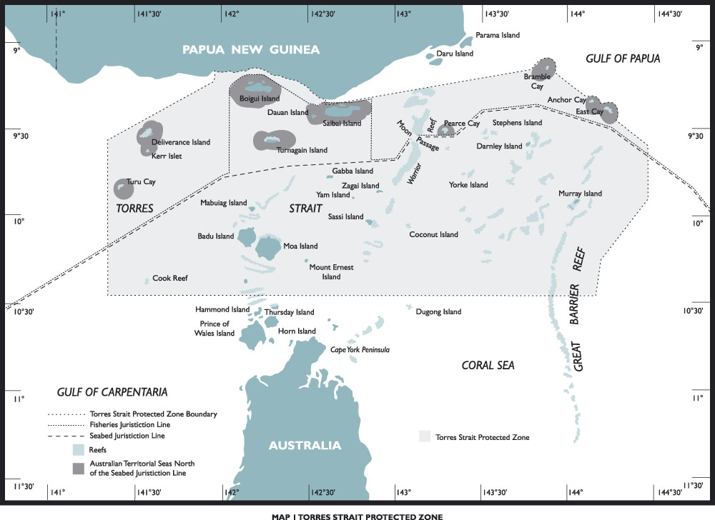
Figure 1 The Torres Strait Protected Zone.

The Torres Strait Fisheries Act 1984
The Torres Strait Fisheries Act 1984 (the Act) came into force on 15 February 1985. The purpose of the Act is to give effect, in Australian law, to the fisheries elements of the Treaty. Section 8 of the Act specifies the objectives to be pursued in the management of Torres Strait fisheries. Section 8 states:
“In the administration of this Act, regard shall be had to the rights and obligations conferred on Australia by the Torres Strait Treaty.”
In October 1988 the PZJA adopted fishery specific objectives for the fisheries under its jurisdiction. These objectives are specified in Section 5 of this report.
In October 2001 the PZJA accepted a recommendation that the Chair of the Torres Strait Regional Authority (TSRA) should be made a full member of the PZJA. The legislation detailing this change to the Act received royal assent on 10 November 2002.
In April 2005, the PZJA agreed to significant changes in the management of the Australian share of the commercial fisheries in the TSPZ (including the outside but near area) and to resolve resource allocation between Traditional Inhabitants and non-Traditional Inhabitants in the Tropical Rock Lobster (TRL) and Finfish fisheries. To facilitate these decisions, the PZJA agreed that changes to the Act were required to:
  - ensure that Torres Strait fisheries can be managed sustainably under appropriate output controls; and
  - improve the operational and administrative efficiency of Torres Strait fishery management arrangements.
Amendments to the Act were passed by the Australian Parliament on 28 June 2007.

3 THE PROTECTED ZONE JOINT AUTHORITY
The PZJA, established under the Act, is responsible for the management of PZJA fisheries. Its members comprise the Commonwealth and Queensland Ministers responsible for fisheries, and the Chair of the TSRA. During 2010–11, the members of the PZJA were:
- The Hon. Tony Burke, MP, former Commonwealth Minister for Agriculture, Fisheries and Forestry (July 2010 to September 2010)
- The Hon. Joe Ludwig, MP, Commonwealth Minister for Agriculture, Fisheries and Forestry (September 2010 to June 2011)
- The Hon. Tim Mulherin, MP, former Queensland Minister for Primary Industries and Fisheries (July 2010 to February 2011)
- The Hon. Craig Wallace, MP, Queensland Minister for Main Roads, Fisheries and Marine Infrastructure (February 2011 to June 2011)
- Mr John T. Kris, Chair of the Torres Strait Regional Authority.
The Commonwealth Minister is the Chair of the PZJA.

Roles and responsibilities
The PZJA is responsible for monitoring the condition of the designated fisheries and for the formulation of policies and plans for their management. The PZJA has regard to the rights and obligations conferred on Australia by the Treaty, in particular the protection of the traditional way of life and livelihood of the Traditional Inhabitants, including the capacity to engage in traditional fishing.
Prior to 1999, the PZJA managed the following designated fisheries in accordance with Commonwealth law in the Australian component of the TSPZ:
- traditional fishing
- those fisheries which Australia and PNG have agreed to jointly manage in the TSPZ under Article 22 of the Treaty including prawns, Spanish mackerel, pearl shell, tropical rock lobster, dugong and turtle
- the barramundi fishery in the territorial waters adjacent to the six Australian islands near the PNG coastline: Saibai, Boigu, Moimi, Kaumag, Aubusi and Dauan.
In October 1996 the PZJA agreed that all fishing in Torres Strait would come under PZJA management. Arrangements were introduced on 1 April 1999 to include the former Queensland managed commercial fisheries.
The following fisheries were incorporated:
- finfish (including Barramundi)
- crab
- trochus
- bêche-de-mer (sea cucumber).
Details on the management arrangements for each of these fisheries are provided in Section 5 of this report. Commercial fishing for any other species not incorporated in the above fisheries is treated as developmental fishing by the PZJA.
In December 2005, the Commonwealth Minister for Fisheries, Forestry and Conservation, set a new direction in Commonwealth fisheries management policy, issuing a formal direction to the Australian Fisheries Management Authority (AFMA) stating that:
“The Australian government considers that decisive action is needed immediately to halt overfishing and to create the conditions that will give overfished stocks a chance to recover to an acceptable level in the near future.”
A key element in implementing the minister’s directive is the development and application of a harvest strategy framework which sets ‘goalposts’ for managing catches by setting agreed target and limit reference points and clear decision rules for each species.
While the minister’s direction does not directly apply to PZJA fisheries, which are jointly managed with Queensland and the TSRA; AFMA is obliged to pursue the objectives set in the December 2005 directive in joint authority fisheries to which the Commonwealth is a party.
In light of this, the PZJA has developed a long term harvest strategy for the Torres Strait Prawn Fishery (TSPF) with a range of rules that control the intensity of fishing activity according to the biological and economic conditions of the fishery. The TSPF harvest strategy will be implemented in the second half of 2011.
The Torres Strait TRL Resource Assessment Group (RAG) have developed harvest control rules for the Torres Strait Tropical Rock Lobster Fishery (TSTRLF) including recommending total allowable catches to be set at levels that maintain escapement close to 1.5 times the equilibrium spawning stock biomass associated with maximum sustainable yield (MSY). The harvest control rules are in line with the Commonwealth Fisheries Harvest Strategy Policy and Guidelines and provides for a precautionary management framework in the TSTRLF. Target and limit reference points for the TSTRLF have been set, however these reference points will be reviewed by the RAG in late 2011, in response to development of a new stock assessment model by the Commonwealth Scientific and Industrial Research Organisation (CSIRO) utilising information from Management Strategy Evaluation research currently underway.
Recreational fishing, including charter fishing, is managed by Queensland under Queensland law. Queensland also retains responsibility for aquaculture and fisheries marketing in the TSPZ. Information on these activities can be obtained from Queensland Primary Industries and Fisheries (QPI&F).

Meetings
The PZJA made a number of out-of-session decisions during the 2010–11 financial year. These decisions are detailed at Annex A (on page 57).

Consultative structure
To assist in the management of the PZJA fisheries, the PZJA has established a consultative process including a structure of advisory bodies (Figure 2 on page 12). The consultative structure incorporates Australian Traditional Inhabitant commercial and traditional fishers, non-Traditional Inhabitant commercial fishers, Australian and Queensland government officials, and technical experts.
The PZJA may be advised by the Standing Committee, Management Advisory Committees (MAC), Scientific Advisory Committee (SAC), and RAG on issues associated with TSPZ fisheries.
Consultation and communication can be difficult across all islands of the Torres Strait, but are important elements in the effective management of the region’s fisheries. The consultative committees are therefore complemented by meetings between fisheries officers and fishers in communities around the Torres Strait. These meetings are occasionally supplemented by fisheries programs broadcast on radio and articles/advertisements in newspapers.
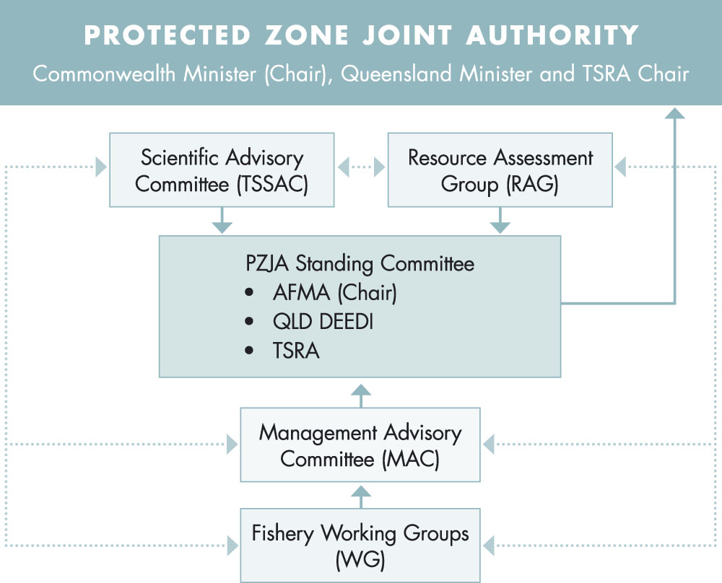
Figure 2 The consultative structure of the Torres Strait Protected Zone Joint Authority (PZJA). Solid lines and dashed line indicate primary and secondary lines of communication respectively.
The committees and groups, outlined in Figure 2 on page 12, are the main avenue for the PZJA to obtain advice and information. However, it is not the only means: the PZJA may seek recommendations, advice and views from others with relevant expertise or interest. This includes PZJA agencies, other government agencies, independent consultants, operators in fisheries more broadly and representatives of the broader community.
While it is recognised that all forums may have common membership, recognised roles and responsibilities differentiate them. Thereby potential conflict of interest, generated by the assessment roles of RAGs and the management advisory roles of other consultative bodies, does not impact on the quality of advice provided to the PZJA.
The full membership of the committees/groups and the dates on which they met during 2010–11 are set out in Annex B on page 59.

Role and functions of the PZJA Standing Committee
The PZJA Standing Committee’s role and function is to provide strategic and operational advice to the PZJA on the management of the fisheries in accordance with the PZJA’s statutory obligations and to oversee the implementation of the PZJA’s agreed policy commitments.

Role and functions of a Management Advisory Committee (MAC)
MACs are the principal source of advice for the PZJA on fishery-specific management issues in all Torres Strait fisheries. A MAC and its working group/s have specific functions that support the decision making process.
Each MAC advises the PZJA on fishery objectives, strategies, reference points, risk profiles and management arrangements for achieving fishery-specific goals. For the PZJA to be able to make decisions based upon MAC advice, the PZJA has to be confident that a MAC has put in place rigorous processes to determine the best package of measures in pursuit of the PZJA’s objectives. Good governance and business efficiency demand that the PZJA is normally able to approve MAC advice without delving into MAC business details, or needing to seek clarification from a MAC.
The role of a MAC is to advise the PZJA on management issues for the fisheries managed under the Act. It provides the forum where issues relating to the fisheries are discussed, problems identified and possible solutions developed. The outcome of these deliberations determines the recommendations a MAC will make to the PZJA concerning the management of relevant fisheries.
Two MACs exist under the PZJA structure; the Torres Strait Prawn Management Advisory Committee (TSPMAC) and the Torres Strait Fisheries Management Advisory Committee (TSFMAC) (for all fisheries other than prawn).

Role and functions of a Scientific Advisory Committee (SAC)
The main role of the SAC is to advise the PZJA on the strategic direction, priorities and funding for research relevant to meeting information needs and objectives of the PZJA and its relevant consultative bodies.
The SAC normally provides a review process for research conducted by research providers to ensure that milestones are met and that the research outcomes represent good value for money. The SAC may also be called upon to make its own assessments of fisheries data and comment on stock assessment results. The SAC may also solicit external review if questions asked fall outside the SACs area of expertise.
The SAC may also provide advice to the MACs, Working Group, and RAG on scientific and research issues in the TSPZ.

Role and functions of a Working Group (WG)
To assist in the operations of a MAC, WGs have been established to provide advice on particular matters relevant to individual fisheries. It is ensured that WGs are both manageable and cost effective and also contain the appropriate blend of knowledge and expertise for providing advice to a MAC.
Ordinarily WGs deal with the fishery specific issues, including the specification of management objectives, research priorities for the particular fishery, management issues and strategies, and compliance issues. In addition to these tasks the WGs deal with a range of ad hoc issues. These are reported to a MAC and/or SAC as appropriate.

Role and functions of a Resource Assessment Group (RAG)
The main role of the RAG is to provide advice on the status of fish stocks, sub-stocks, species (target and non-target species) and on the impact of fishing on the marine environment. Advice provided by a RAG should address biological, economic and wider ecological factors affecting the fishery.
A RAG should also evaluate alternative harvest options proposed by the relevant fishery WG and/or MAC. This includes advising on the impact over time of different harvest strategies (for example, the time required for a particular fish stock to reach a reference point), stock depletion or recovery rates, the confidence levels of the fishery assessment, and risks to the attainment of approved fishery objectives.
A RAG directly informs the SAC, relevant MACs or WGs of stock assessment related matters. The TRLRAG is the only RAG at present.

4 COOPERATION WITH PAPUA NEW GUINEA
The Treaty requires Australia and PNG to cooperate in the conservation, management and optimum utilisation of all of the Article 22 commercial fisheries of the TSPZ.

Catch sharing
Articles 22 and 23 of the Treaty allow for the sharing of catch within the TSPZ. The catch-sharing arrangements with PNG for 2011 were agreed to at the Australia-Papua New Guinea Fisheries Bilateral meeting held on 7 October 2010 in Cairns, Australia. The key outcomes from this meeting were:
- Torres Strait Prawn Fishery—both parties agreed to catch sharing arrangements for 2011. Australia accepted PNG’s offer of its entitlement of 2104 fishing days but these were not utilised in the fishery
- Torres Strait Tropical Rock Lobster Fishery—both parties agreed on catch sharing arrangements for the 2011 fishing season with PNG to access the Australian jurisdiction for 968 dory days in 2011 for a maximum of seven freezer boats with a maximum of seven dories each
- Spanish mackerel Fishery—both parties agreed that catch sharing requirements were not required for the 2011 season
- Pearl Shell Fishery—both parties agreed that catch sharing requirements were not required for the 2011 season.

Outside but near areas
Fish stocks can extend across jurisdictional boundaries. The Treaty provides for the two countries to agree to management and conservation measures in areas extending beyond the TSPZ.
The Act, and its PNG equivalent, allows Australia and PNG to extend their TSPZ management arrangements into “outside but near areas” to the TSPZ. One of the management and conservation measures in place is a prohibition on the incidental taking and carrying of TRL by prawn trawlers in the TSPF and in certain waters outside but near the TSPZ. This measure has been in place since 1988.

5 FISHERIES
Torres Strait fisheries can be subdivided into two broad categories, Article 22 fisheries and non-Article 22 fisheries, both of which include traditional and/or commercial fisheries.
Article 22 fisheries are those fisheries where the mechanism identified in Article 22 of the Treaty has been exercised by Australia and PNG, whereby common conservation and management arrangements have been negotiated and applied to specified fisheries. Article 22 fisheries are primarily those with commercial sectors as well as the turtle and dugong fisheries.
Non-Article 22 fisheries are those that are not managed in conjunction with PNG.
All Torres Strait fisheries are assessed under three parts of the Environment Protection and Biodiversity Conservation (EPBC) Act 1999.
- Part 10 of the EPBC Act requires that fisheries must be strategically assessed before a management plan is determined.
- Part 13 of the EPBC Act allows for interactions with listed threatened species and ecological communities as long as the management plan has been accredited and fishers are operating under their management plan or regime.
- Part 13A of the EPBC Act allows the determination of whether species taken in the fishery are allowed to be exported.
AFMA has been conscientious in ensuring compliance with conditions and/or recommendations. AFMA ensures that any required reports to SEWPAC are lodged, although there may sometimes be delays in doing so.

Commercial fisheries
Commercial fishing is one of the most important economic activities in the TSPZ and provides a significant opportunity for financial independence for Traditional Inhabitant fishers (holders of Traditional Inhabitant Fishing Boat Licences (TIB)). The PZJA has a policy of enhancing the opportunities for Traditional Inhabitant participation in all sectors of the fishing industry.
Apart from the TSPF where only non-indigenous fishers are licenced, a limited number of non-Traditional Inhabitants participate in some other TSPZ commercial fisheries. The PZJA has prevented expansion of this group as required by the Treaty. This means that non-Traditional Inhabitants must purchase an existing Torres Strait Fishing Boat Licence (TVH) or lease a Sunset Licence to gain access to a fishery. Where there is scope for expansion in Torres Strait fisheries, the PZJA has reserved expansion to Torres Strait Traditional Inhabitants.

Traditional fisheries
Traditional inhabitants of the Torres Strait have always exploited a diverse range of marine animals for subsistence and use in cultural activities (unlicensed non-commercial fishing) including dugong, turtle, TRL, finfish, shellfish, crab, and octopus. As such, sea-based resources are of significant importance to Torres Strait islanders and aboriginals.
The most important are dugong, green turtle and a variety of finfish and shell fish. The relative importance of each group varies between island communities and throughout the year. With respect to commercial and artisanal fishing activities, fishery resources such as TRL, Spanish mackerel, reef fish and pearl remain of significant importance to these communities.
The most common fishing activities undertaken by Traditional Inhabitants for subsistence include hand lining for finfish and diving for many species including TRL. Other means of gathering seafood include spearing, reef gleaning (gathering of benthic macro invertebrates in intertidal areas), cast-netting, traditional hunting for dugong and turtle, gill netting, trolling from dinghies, crabbing, seining, jigging for squid, hand collection for species such as trochus, and trading with PNG. In general, men fish from boats away from the home island and women and children fish on fringing reefs around the island.
It is difficult to assess all species separately because of the diverse range of marine animals taken in the course of traditional fishing. However, studies undertaken during the 1980s, 2007 and 2008 (Evaluation of the Eastern Torres Strait Reef Line Fishery by Williams et al, 2007 and The Subsistence Coral Reef Fish Fishery in the Torres Strait by Busilacchi, 2008), indicate the high level of importance seafood is to Torres Strait Islanders. While rates of exploitation may have increased during the intervening period, it is unlikely that they are now excessive.
There were no changes to formal management arrangements for traditional fishing activities during 2010–11. The only management restrictions existing in the 2010–11 period relate to dugong and turtle, and bag limits on TRL and bêche-de-mer (sea cucumber).

Article 22 fisheries
Following is a summary of each of the Article 22 fisheries during 2010–11. Note that landing data in this report is presented by calendar year due to the fact that most fisheries data is collected and presented to industry by calendar year.

PRAWN
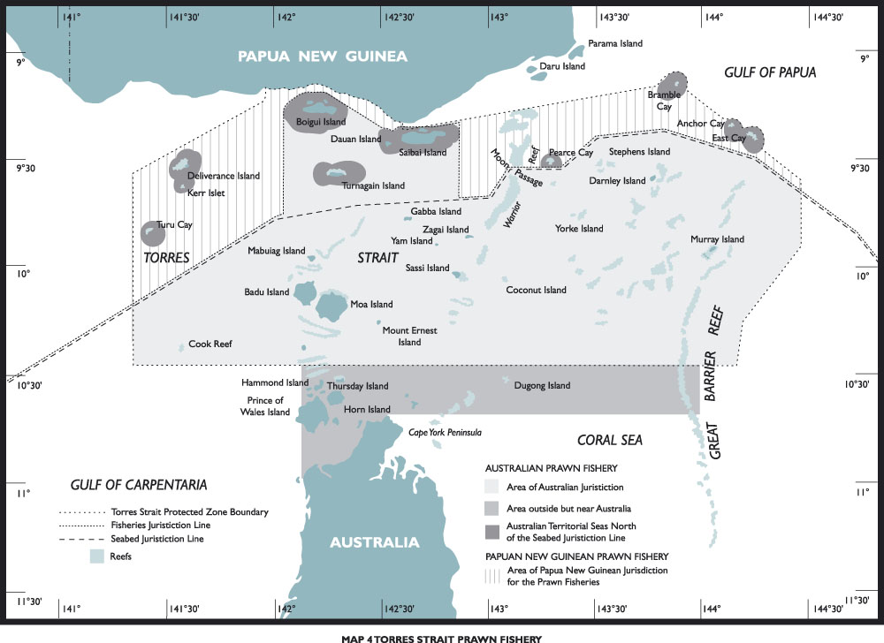
Figure 3 Torres Strait Prawn Fishery.

Description of the fishery
The TSPF (Figure 3) is one of the more valuable commercial fisheries in the Torres Strait. Four hundred and eighty eight tonnes of product was caught in the 2010 fishing season. The fishery GVP was estimated at over $3.8 million for the
2010–11 financial year (Woodhams et al., 2011). The TSPF is a multi-species prawn fishery which operates in the eastern part of the Torres Strait. Brown tiger prawns (Penaeus esculentus) and blue endeavour prawns (Metapenaeus endeavouri) are the key target species. Red spot king prawns (Melicertus longistylus), Moreton Bay bugs (Thenus spp.), scallops (Amusium spp.), slipper and shovel-nosed lobster (Scyllaridae) and squid (Teuthooidea) are taken as by-product.
Fishing is permitted in the TSPF from 1 March to 1 December each year and is limited by a Total Allowable Effort (TAE) in the form of fishing days. Fishing for prawns in the TSPF occurs at night, primarily using the otter trawl method which involves towing two, three or four trawl nets behind a vessel. The TSPF has restrictions on the quantity of net and length of vessel that can be used to operate in the fishery.
The following information for the TSPF including the data presented in Table 1 on page 20 is based on the 2010 fishing season
(1 March to 1 December 2010).

Management objectives
For the 2010 fishing season the TSPF operated in accordance with the objectives under the Torres Strait Prawn Fisheries Management Plan to:
- control effort in the fishery and provide for catch sharing to occur with PNG
- encourage Traditional Inhabitants to participate in the TSPF
- optimise utilisation of fishery resources within the TSPF, is consistent with the principles of ecologically sustainable development and the exercise of the precautionary principle
- promote economic efficiency in the utilisation of the fisheries resources within the TSPF
- ensure cooperative, efficient and cost effective management of the fishery
- manage the fishery’s interactions with the marine environment including the incidental capture of non-target species and impacts on demersal habitats.
These objectives were to be achieved in a manner that minimised negative impacts to other fisheries and the marine environment.

Management arrangements under the Torres Strait Prawn Fisheries Management Plan 2009
The Torres Strait Prawn Fisheries Management Plan 2009 was introduced in 2009 and moved the fishery from being managed by days to Units of Fishing Capacity (UFC). These units were initially allocated to the 61 Australian licence holders on a one for one basis, with one UFC for each fishing day previously held. The value of each unit will change between seasons dependant on the TAE for the season. Under the Plan the maximum number of boat licences in the fishery remains capped at 61 and the number of UFCs is capped at 9,200. Under the Plan, 6,867 units are allocated to Australian operators, and 2,333 are held in trust by the Commonwealth; a portion of this is then allocated to PNG under catch sharing arrangements each year. In 2010 PNG agreed to allow Australia to utilise their 25 per cent of the Australian allocation under the Treaty catch sharing arrangements. Although Australia accepted this effort, it wasn’t used due to the large level of latent effort in the fishery.
The TSPF is a cost recovered fishery through levy fees. The levies are implemented prior to each season through regulations that are updated each year—Fisheries Levy (Torres Strait Prawn Fishery) Amendment Regulations.
A Bycatch Action Plan (BAP) has been in place for the TSPF since 2005. The primary aims of the TSPF BAP are to:
- eliminate, to the greatest extent feasible, the catch of large animals such as turtles and stingrays
- substantially reduce the ratio of bycatch to prawns.
To achieve these aims, the BAP has adopted the following strategies to:
- modify fishing gear to minimise bycatch, including mandatory use of Turtle Excluder Devices
- ensure bycatch is monitored in the TSPF
- continue to make information available to fishers and the community regarding bycatch.
A harvest strategy for the TSPF is also under development by the PZJA agencies and is due to be finalised in the 2011–12 financial year. The harvest strategy will provide a framework for the setting of effort levels within the fishery together with control rules so that management is more transparent and logical and the fishery meets pre-defined ecological and economic goals.

Condition of the fishery
The estimated fishing effort level to achieve Maximum Sustainable Yield (MSY) in the fishery is 9,200 days. The fishery would be considered to be fully exploited in a given season if the level is achieved. Historically the fishery has operated at much lower levels. Additionally, the PNG portion of effort was not fished during the 2011 season.
In 2010, only 1,538 of the available 9,200 days allocated to Australian operators were used (2010 logbook data). The catch since 1999 has declined steadily from 2,200 to 487 tonnes in 2010 (Figure 4). Species composition for the 2010 fishing season is shown in Table 1 on page 20.
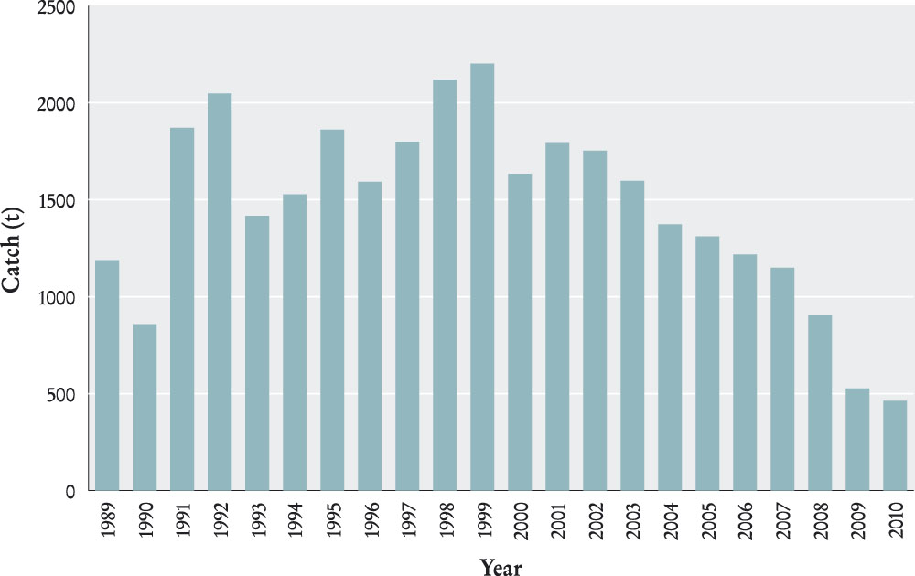
Figure 4 Annual catches of all prawn species in the TSPF 1989–2010. Data is presented in fishing seasons (1 March to 1 December) (Source: Logbook data 1989–2010).
Table 1 Prawn and bug catches in the TSPF for the 2010 season (1 March to 1 December 2010) (Source: Logbook data 2010).
Species | Catch (tonnes)
Blue Endeavour Prawns (Metapenaeus endeavouri) | 109.7
Brown Tiger Prawns (Penaeus esculentus) | 343.9
Red Spot King Prawn (Melicertus longistylus) | 3.7
King Prawns (Merlicertus plebejus) | 5.2
Bugs | 17.3
Other | 7.0
Total | 486.8

Strategic assessment—update
With the implementation of the Plan in 2009, the TSPF was strategically assessed under the Environment Protection and Biodiversity Conservation Act 1999 (EPBC Act) to be re-accredited as a Wildlife Trade Operation (WTO). On 27 February 2009 the TSPF was formally declared a WTO for three years to 25 February 2012 by SEWPaC. A re-assessment of the TSPF will occur in the 2011-12 financial year.

TROPICAL ROCK LOBSTER
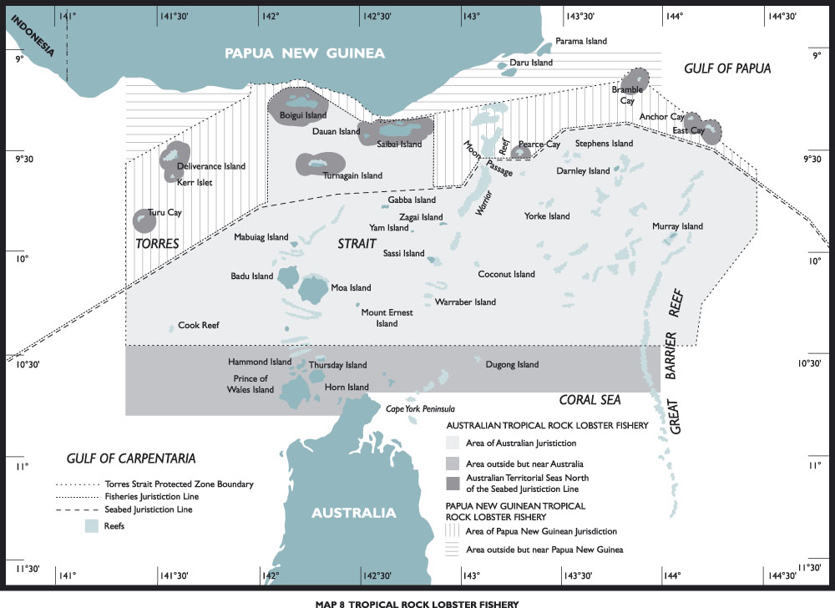
Figure 5 Tropical Rock Lobster Fishery.

Description of the fishery
The TSTRLF (Figure 5) is the most valuable commercial fishery in the Torres Strait. It is a single species fishery targeting the ornate tropical rock lobster (Panulirus ornatus) and is an important commodity to both Traditional Inhabitants and non-Traditional Inhabitants. Lobster is collected by hand, short hand spear or loops by divers working from dinghies. Scoop nets are used during night spearing activites. Divers free dive on shallow reef tops or use hookah equipment (surface supplied air) to dive deeper areas of the Torres Strait. Most fishing occurs during neap tides when currents ease and underwater visibility improves.
The commercial fishing season for lobster is from 1 December through to 30 September the following year, with the use of hookah gear prohibited from 1 October to 31 January. The peak effort period for the TSTRLF occurs from March to August. In comparison, Traditional Inhabitants fishing for subsistence (traditional catch) can take lobster at any time of the year with restrictions being:
- up to three lobsters per person without the use of a boat, or where there is only one person aboard the boat; or
- up to six per boat where there is more than one person aboard the boat.

Management objectives
Management objectives for the TSTRLF, adopted at PZJA 19 (27–28 April 2006) and PZJA 20 on (25-26 October 2006), and applicable for 2010-11 are to:
- maintain the spawning stock at levels that meet or exceed the level required to produce the maximum sustainable yield
- protect, in accordance with the Treaty, the traditional way of life and livelihood of Traditional Inhabitants, in particular in relation to their traditional fishing for lobster
- provide for the optimal utilisation, cooperative management with Queensland and PNG and for catch sharing to occur with PNG
- monitor interactions between the prawn and TSTRLF
- maintain appropriate controls on fishing gear allowed in the fishery to minimise impacts on the environment
- promote economic development in the Torres Strait area with an emphasis on providing the framework for commercial opportunities for Traditional Inhabitants and to ensure that the opportunities available to all stakeholders are socially and culturally appropriate for the Torres Strait and the wider Queensland and Australian community
- optimise the value of the fishery.

Management arrangements
Management arrangements as outlined in Fisheries Management Notice No. 80 were applicable during 2010–11 and include:
- limiting the method of taking of lobster to either hand or with the use of a hand held implement, such as a spear or scoop net
- seasonal closures – complete closure from October-November (inclusive) and hookah equipment closure from December-January (inclusive)
- size limits for all commercial and recreational take – minimum tail size of 115 mm or minimum carapace length of 90 mm
- bag limits for traditional and recreational fishing – three lobsters per person or six per boat, if there is more than one person in the boat
- a prohibition on the processing or carrying of lobster meat that has been removed from any part of the lobster on any boat.
In addition to the above-mentioned management arrangements, expansion in the fishery is limited to Traditional Inhabitants. A number of provisions are in place to prevent the expansion of the non-Traditional Inhabitant sector including:
- a boat replacement policy which aims to control fishing capacity by preventing the introduction of larger more efficient boats
- a ban on trawlers taking lobster to prevent pressure on the lobster resource from the prawn trawling fleet.
Since 2003, a number of interim measures have been agreed to annually and implemented as a means of reducing effort in the non-Traditional Inhabitant sector. During 2010–11 interim measures included:
- a 30 per cent reduction in the number of months that tenders were allowed to operate for licence holders that have two or more tenders associated with a primary vessel. In practice, this meant that licence holders could work some of their tenders for the entire season but others ceased operation at various times to effect the reduction
- a prohibition on the use of hookah equipment three days before, on, and three days after either the full or new moon each month from February to September.

Condition of the fishery
For 2010, the status of the lobster stocks in the TSPZ was assessed as ‘not overfished’ and ‘not subject to overfishing’ (Flood et al, 2011 in Woodhams et al., 2011).
During 2010 the nominal Total Allowable Catch (TAC) for lobster in the TSPZ was 853 tonnes (based on a mid-season survey and harvest control rule recommended by the TRL RAG). This resulted in nominal allocations of 576 tonnes to Australian fishers and 277 tonnes to PNG fishers. The PNG share was converted to 1036 dory days under the agreed catch sharing model.
The total reported Australian catch of 471 tonnes (Figure 6) in 2010 accounted for 85 per cent of the recommended Australian share of the TAC. The Australian fishery was valued at around $11 million in 2010.
In January 2011 there were 268 TIB licences and 13 TVH licences in the TSTRLF.
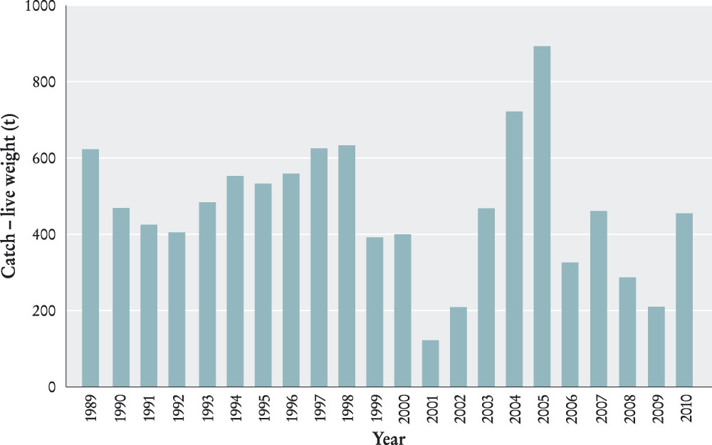
Figure 6 Annual catch of the TSTRLF 1989–2010 in the Australian Jurisdiction (Source: Logbook data 1989–2010, docket book data 2004–2010 and other records).

Strategic assessment—update
The TSTRLF was accredited as a WTO on 17 January 2011 until 23 November 2013 under the EPBC Act. This WTO declaration is subject to the conditions and recommendations developed by SEWPaC.

FINFISH (SPANISH MACKEREL)
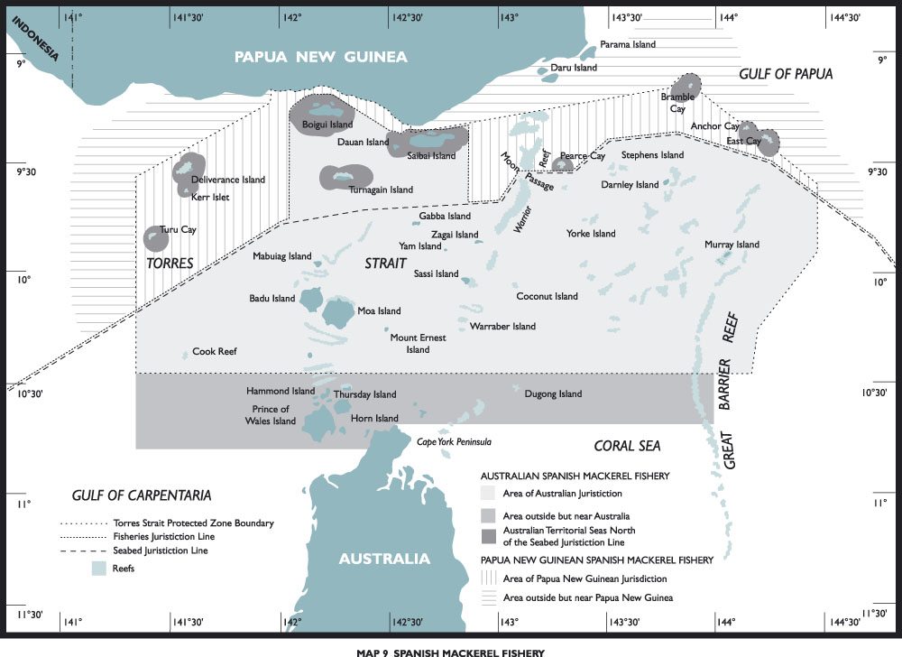
Figure 7 Spanish Mackerel Fishery.
The Torres Strait Spanish Mackerel Fishery (Figure 7) operates predominantly in the eastern Torres Strait, targeting the narrow-barred Spanish mackerel (Scomberomorus commerson). In 1999, other species were added to the list of permitted species including school mackerel (S. queenslandicus), grey mackerel (S. semifasciatus), Spotted mackerel (S. munroi), and shark mackerel (Grammatorcynus bicarinatus). Spanish mackerel are fished by trolling, generally from dories/dinghies operating either to a primary vessel or by themselves.
While Spanish mackerel is not generally targeted by Traditional Inhabitants, a large number of TIB licence holders take the species opportunistically.
In 2007–08, a voluntary buy-back of the 17 TVH licences endorsed to fish in the Torres Strait Finfish Fishery (Spanish mackerel) resulted in a transfer of all Australian fishing catch entitlements to the Traditional Inhabitant sector. These entitlements are held in trust by the TSRA or held for PNG in accordance with the Treaty. However, leasing arrangements are in place to allow for non-Traditional Inhabitants to continue participating in the fishery by leasing a Sunset Licence from TSRA with a condition of an agreed limit on the harvest of Spanish mackerel allowed for on that licence.
In 2010–11 three Sunset Licence packages were issued to
non-Traditional Inhabitant fishers to fish for a collective total of 85 tonnes of Spanish mackerel in the Torres Strait.

Management objectives
The management objectives for the Torres Strait Spanish Mackerel Fishery for 2010-11 are to:
- manage the mackerel resource to achieve its optimal utilisation
- maximise the opportunities for Traditional Inhabitants of both Australia and PNG to participate in the commercial fishery
- promote the fishery as a line fishery.
The management objectives for this fishery will be reviewed as part of the development of the Torres Strait Finfish Fishery Management Plan.

Management arrangements
The management arrangements for the fishery are as per Fisheries Management Notice No. 79 and include:
- gear restrictions
- minimum size limits
- effort restrictions.
A management plan for the Torres Strait Finfish (Reef Line and Spanish Mackerel) Fishery is being drafted and is set for release for public comment in early 2012. The management objectives and arrangements for the Torres Strait Spanish Mackerel Fishery will be reviewed as a part of this process.

Condition of the fishery
Available information for the Torres Strait Spanish Mackerel Fishery indicates that the Spanish mackerel stock was fully exploited prior to 2007. However, the result of the buyout, in 2007 and 2008, has reduced the catch and effort in the fishery. In 2009 and 2010 Spanish mackerel in the TSPZ was not considered to be overfished or subject to overfishing (Woodhams et al., 2011).
During the 2010 season, information on the quantity of Spanish mackerel taken by Traditional Inhabitants was collected through the non-compulsory docket book system. Therefore, the catch data presented is estimated. The quantity of Spanish mackerel taken for traditional purposes is unknown.
The catch of Spanish mackerel in 2010 was approximately 88 tonnes (whole weight) (Figure 8) with a value of approximately $0.78 million (AFMA, 2010).
At January 2011 there were 131 TIB licences with Spanish mackerel entries.
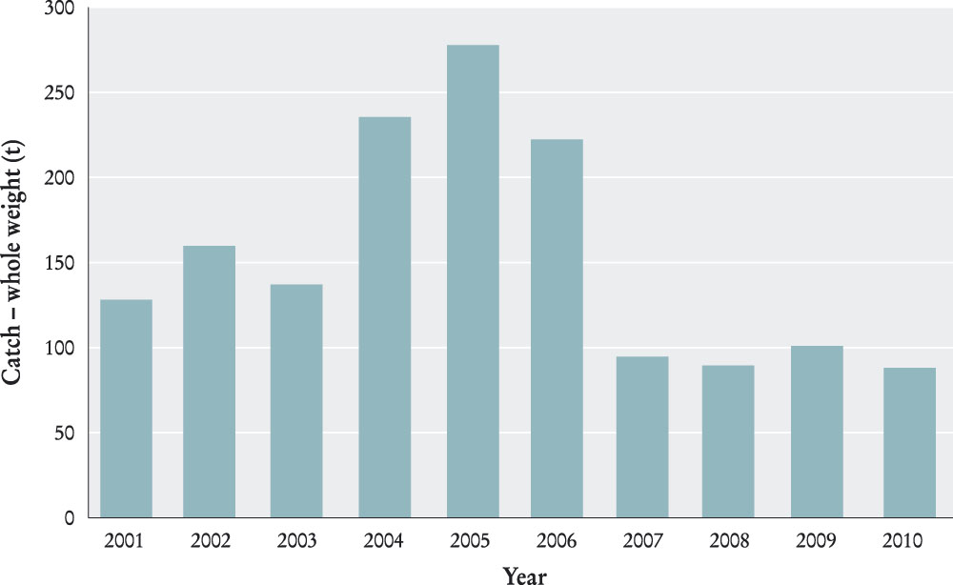
Figure 8 Catches of Torres Strait Spanish mackerel (S. commerson) (Source: Logbook data docket book data 2004-2010 and other records 2001–2010).

Strategic assessment—update
The fishery was strategically assessed under the EPBC Act in 2008 and was formally accredited as a WTO in November 2008. SEWPaC also provided a number of accreditation recommendations to improve the sustainability of the fishery. The export accreditation is valid until 25 November 2011.

PEARL SHELL
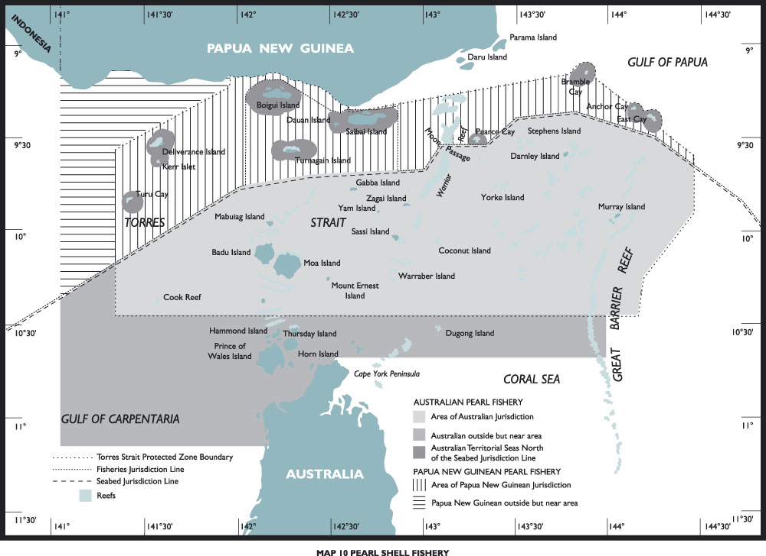
Figure 9 Pearl Shell Fishery.

Description of the fishery
The PZJA is responsible for the management of wild pearl shell collection in the Torres Strait (Figure 9). Aquaculture farming of pearl shell is regulated and managed by the Queensland Department of Employment, Economic Development and Innovation (DEEDI).
The gold-lipped pearl shell (Pinctada maxima) is the main species targeted in the Torres Strait, although at least another six species, including the black-lipped pearl shell (P. margaritifera) and the winged pearl oyster (Pteria penguin) also occur. Pearl shell is collected live for pearl culture farms, principally by divers using hookah equipment (surface supplied air). Few boats specialise in collecting pearl shell, primarily through the months of October to March, although a number of licences also have lobster endorsements allowing divers to collect pearl shell whilst fishing for lobster.

Management objectives
Management objectives for the Torres Strait Pearl Shell Fishery (TSPSF) for 2010–11 are to:
- conserve the stock of pearl shell to achieve its optimal utilisation
- maximise the opportunities for the Traditional Inhabitants of Australia and PNG to participate in this fishery.

Management arrangements
Expansion of licence numbers in the TSPSF is limited to Traditional Inhabitants in order to maximise their opportunities.
Provisions applying to the non-Traditional Inhabitant sector of the fishery include a prohibition on the issue of boat and master licences, strict boat replacement policies, and the linking of tender boats with specific primary boats.
Current management regulations require divers to harvest only live shells, and adhere to size limits of 130 mm minimum and 230 mm maximum for gold-lip pearl oyster, and 90 mm minimum for black-lip pearl oyster. There is a ban on the taking of shell by any method other than collecting by hand.

Condition of the fishery
Based on past surveys, the abundance of pearl shell on the main fishing grounds is low, and the stock status remains uncertain.
There have been insignificant amounts of pearl shell harvested since at least 2006.
As at January 2011 there were 40 TIB licences with pearl shell endorsements.

Strategic Assessment—update
The TSPSF has not undergone a strategic assessment due to insignificant pearl shell harvesting. It may in the future depending on activity in the fishery.

DUGONG AND TURTLE
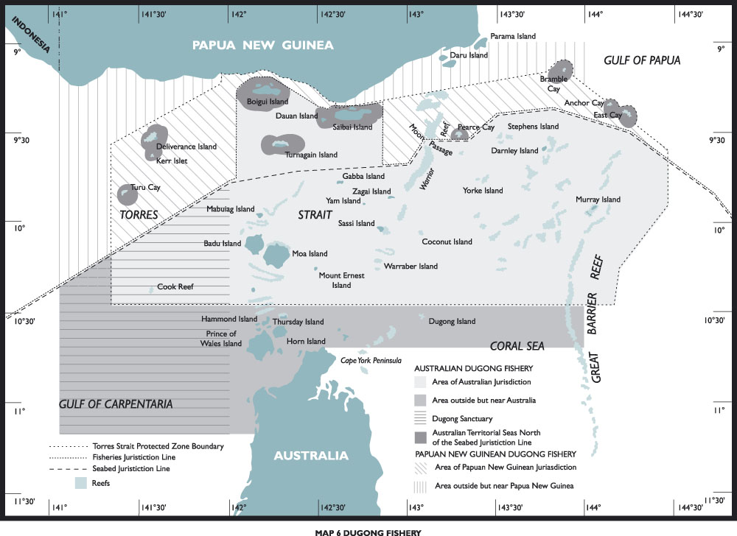
Figure 10 Dugong Fishery.
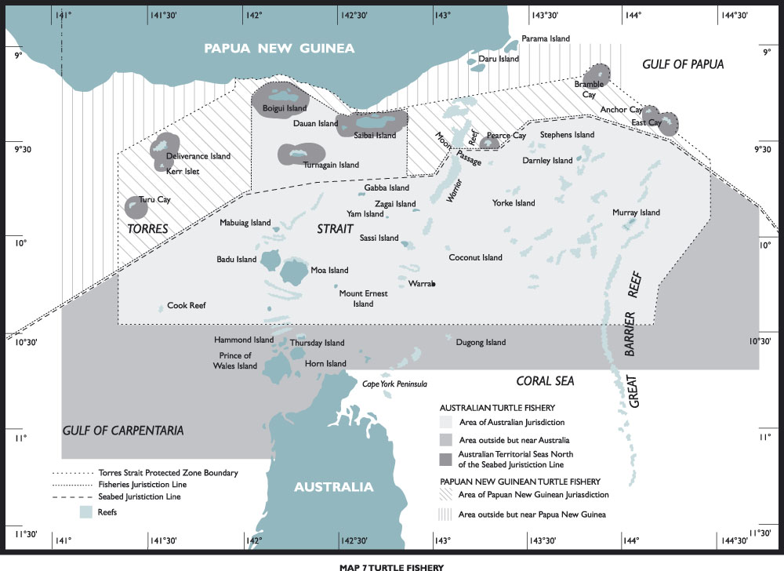
Figure 11 Turtle Fishery.

Description of the fisheries
The Torres Strait Dugong and Turtle Fisheries (TSD&TF) (Figures 10 and 11) are traditional subsistence fisheries limited to Traditional Inhabitants of the Torres Strait. Hunting for dugong and turtle is an important part of the traditional way of life and livelihood of the Traditional Inhabitants of the Torres Strait and is also a major source of protein in their diet. Dugong (Dugong dugon) and turtles are hunted using a traditional spear (wap) thrown by hand from a dinghy. Turtles are also caught by hand from a dinghy. In some areas of the Torres Strait, nesting turtles are taken off the beach. Turtle eggs are also harvested.
Turtles are taken in all areas of the Torres Strait, while dugongs are caught mainly in the western region.
Strong partnerships have been established in regards to research into dugongs and turtles between Torres Strait Island communities, Torres Strait Regional Authority (TSRA), relevant Registered Native Title Body Corporations and research providers. Research projects include dugong aerial surveys, turtle tagging, turtle foraging population surveys, nesting turtle tagging surveys and migration surveys through satellite tracking for both dugongs and turtles.
A dugong taskforce was established to report to the Commonwealth and State Environment Ministers on the coordinated framework for conservation and management of dugong in Queensland.

Management objectives
Management objectives for the TSD&TF in 2010–11 are to:
- promote the conservation of dugong and turtle stocks
- restrict the take of dugongs and turtles to Traditional Inhabitants fishing for traditional purposes.

Management arrangements
Participation in the TSD&TF is restricted to Traditional Inhabitants of the Torres Strait and PNG Treaty villages for traditional purposes.
A dugong sanctuary in the south-western area of the Torres Strait has been established where dugong hunting is not permitted. Outside this area dugongs may only be taken using a wap.
In addition, dugongs and turtles cannot be taken or carried in a commercially licensed fishing boat greater than 6 meters in length. TIB licensed boats less than 6 meters in length are permitted to take and carry dugong and turtle.
Community-based Dugong and Turtle Management Plans are now being rolled out in all Torres Strait island communities. These management plans include a range of culturally-based and legislated management arrangements that are implemented at a community level. Arrangements in each community differ slightly.
A Torres Strait Indigenous Ranger Program is being rolled out as a means of implementing these community-based management plans. In 2010–11 the ranger program was established at Badu, Boigu, Darnley (Erub), and Yam (Iama) in addition to the already established ranger group on Mabuiag Island. Roll out of the ranger program to the remaining Torres Strait communities is proposed during 2010–11.

Condition of the fisheries
Dugong: The Torres Strait dugong population has been estimated through aerial surveys in 1987, 1991, 1996, 2001, 2006 and 2011. These surveys covered the central waters of the Torres Strait and adjacent coastal waters of Cape York and PNG, including areas of the western waters of the Torres Strait not previously surveyed. The 2011 population estimate was 15,526 ± s.e. 1,915 individual dugong. No current estimate exists for the harvest of dugong.
The 2011 survey revealed that there is no significant decline of dugong numbers in the Torres Strait across the series of surveys and the population size is considered substantial and genetically healthy (Marsh et al., 2011). Since 1976, estimated annual catches have ranged from 240 to more than 800 individuals. Current harvest rates are unknown, but the implementation of community-based management plans includes community-based catch monitoring.
Turtle: There are no population estimates for turtle stocks in the Torres Strait. However, the monitoring of key turtle nesting sites in north Queensland has raised concerns about the green turtle (Chelonia mydas) and hawksbill turtle (Eretmochelys imbricata) stocks. As a result, there is a growing awareness of the need to manage the impacts on turtles (particularly nesting success) to ensure the long term viability of these populations. No current estimate exists for the harvest of turtles however the implementation of the community-based management plans includes community-based catch monitoring.
Other turtle species are not generally taken for food, however, the eggs of the hawksbill, flatback (Natator depressus), and green turtles are regularly harvested by Traditional Inhabitants. The level of annual egg harvest is unknown.

Habitat
Seagrass meadows are the primary food resource for turtle and dugong and habitat for fish species. Approximately 30 per cent of Queensland’s seagrass meadows are in the Torres Strait. These meadows are being assessed and monitored by the TSRA in partnership with DEEDI. A 2009/2010 survey of the Torres Strait dugong sanctuary found it has one of the largest single continuous seagrass meadows recorded in Australia.
Intertidal seagrass sites are being monitored by the TSRA in partnership with Seagrass-Watch (DEEDI). Results from these sites indicate that seagrass is in a good condition and increasing in abundance at some locations. The large areas of seagrass found in the relatively shallow waters of the Torres Strait supports the view that the Torres Strait is an important refuge for dugong and turtle in Queensland and northern Australia.

Strategic assessment—update
The Strategic Assessment Report of the Torres Strait Turtle and Dugong Fisheries was submitted to SEWPaC in 2007 after consideration by the TSFMAC, the AFMA Environment and Research Committee and the PZJA. SEWPaC has made several recommendations in consultation with Torres Strait communities and relevant government agencies. The strategic assessment is yet to be finalised.

Non-article 22 fisheries
A summary of the fisheries not managed in conjunction with PNG (non-Article 22 fisheries) for 2010–11 are detailed below. Landing data is presented by calendar year.

FINFISH (REEF LINE)
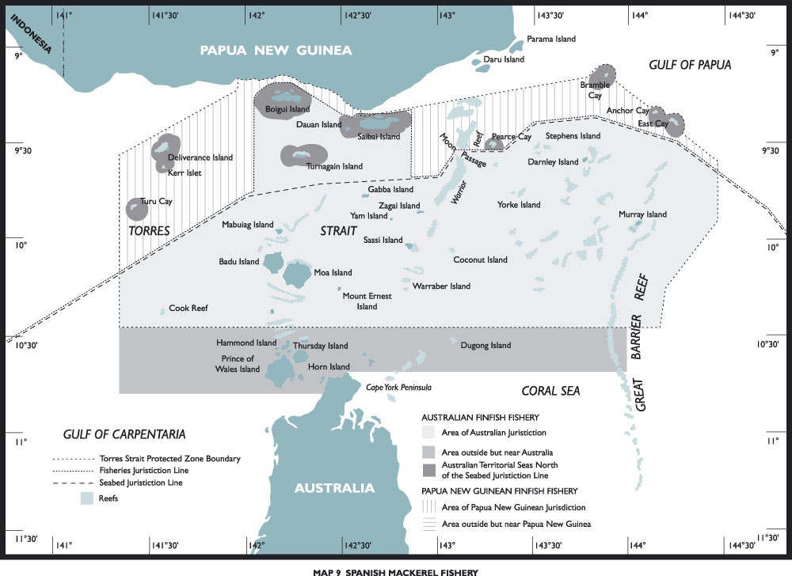
Figure 12 Reef Line Fishery.

Description of the fishery
The Torres Strait Finfish (Reef Line) Fishery (Figure 12) is a multi-species fishery targeting a range of reef fish species. The fishery focuses primarily on the highly valued coral trout species (Plectropomus spp.), barramundi cod (Cromileptes altivelis), mixed reef fish (Lutjanus spp. and Lethrinus spp.), and numerous species of rock cod (Epinephelus spp.). Barramundi (Lates calcarifer) harvest included in the Torres Strait Finfish Fishery is limited to the territorial waters adjacent to the six Australian islands in the north-west of the Torres Strait near the PNG coast: Saibai, Boigu, Moimi, Kaumag, Aubusi and Dauan. Most of the barramundi taken in these communities is for subsistence and there are no records of commercial sales of this species.
Finfish are generally taken by hand lines and since December 2005 the use of nets has been banned throughout the TSPZ and the outside but near area. This ban may be reconsidered in future to allow for a small net fishery around the communities of Boigu, Dauan and Saibai targeting barramundi.
In 2007–08, a voluntary buy-back of the nine TVH licences endorsed to fish in the Torres Strait Finfish Fishery (Reef Line) resulted in a transfer of all fishing catch entitlements to the Traditional Inhabitant sector. These entitlements are held in trust by the TSRA or held for PNG in accordance with the Treaty. However leasing arrangements are in place to allow non-Traditional Inhabitants to continue participating in the fishery by leasing a Sunset Licence from TSRA with a condition of an agreed limit on the harvest of coral trout species allowed for on that licence. In 2010–11 one sunset licence package was issued to a non-Traditional Inhabitant fisher to fish for 50 tonnes of coral trout in the Torres Strait.

Management objectives
The management objectives for the Torres Strait Finfish (Reef Line) Fishery were developed in conjunction with the objectives of the Act and the Treaty. The objectives reflect the status of the fishery following the change in jurisdiction from a fishery managed solely under Queensland law to one managed by the Commonwealth in 1999. The objectives adopted include to:
- manage the resource to achieve its optimum utilisation
- maximise opportunities for Traditional Inhabitants of Australia and PNG to participate in the commercial fishery.
The management objectives for this fishery will be reviewed as part of the development of the Torres Strait Finfish Fishery Management Plan.

Management arrangements
In the interim, the existing management arrangements apply as per Fisheries Management Notice No. 78 and include:
- gear restrictions
- minimum and maximum size limits
- no-take species
- restriction on retaining live fish
- restriction on shark finning and discarding the torso
- permanent closure west of latitude 142°31'49”
- a seasonal closure for barramundi.
There are amendments to the Fisheries Management Notice relating to net size restrictions and removal of restriction of live fish in being considered in 2010–11. The amendments will be included in a Fisheries Management Instrument due for release in 2011–12.
A management plan for the Finfish (Reef Line and Spanish Mackerel) Fishery is being drafted and set for release for public comment in early 2012. The management plan will include arrangements for the Torres Strait Spanish Mackerel Fishery as well as the reef fish species.

Condition of the fishery
In 2009 and 2010, coral trout species (Plectropomus spp. and Variola spp.) in the TSPZ were not considered to be overfished or subject to overfishing (Woodhams et al., 2011).
In 2010, the Torres Strait Finfish (Reef Line) Fishery was considered to be under exploited with landed species totalling 39.6 tonnes. Coral trout made up the majority of the catch (36.2 tonnes, Table 2). Between 2001 and 2004 catches of coral trout were relatively stable, however from 2004 catches declined substantially (Figure 13) reflecting the reduced effort and number of operations in the fishery. The 2010 season catch of coral trout (36.2 tonnes) had an estimated value of $0.69 million.
Table 2 Logbook catch data from the Torres Strait Finfish (Reef Line) Fishery (including catches from both TIB-licensed boats and Sunset-licensed boats) received during 2010.
Species | Catch (kg)
Coral trout | 36,195
Red emperor | 327
Barramundi cod | 926
Other | 2169
Total | 39,617
Based on data collected from fish buyers, it is estimated that of the 117 licensed TIB fishers with a reef line entry, few participated in the Reef Line Fishery in 2010. It is important to note though, that Traditional Inhabitants are not required to complete individual catch returns. Therefore, the quantity of finfish taken by Traditional Inhabitants with TIB licences may be underestimated.
The level of Traditional Inhabitant commercial fishing in this fishery may increase in future due to the high value of the target species and the fact that this fishery provides an important economic development opportunity for Traditional Inhabitants in the eastern Torres Strait. An unknown quantity of finfish is also taken during the course of traditional fishing.
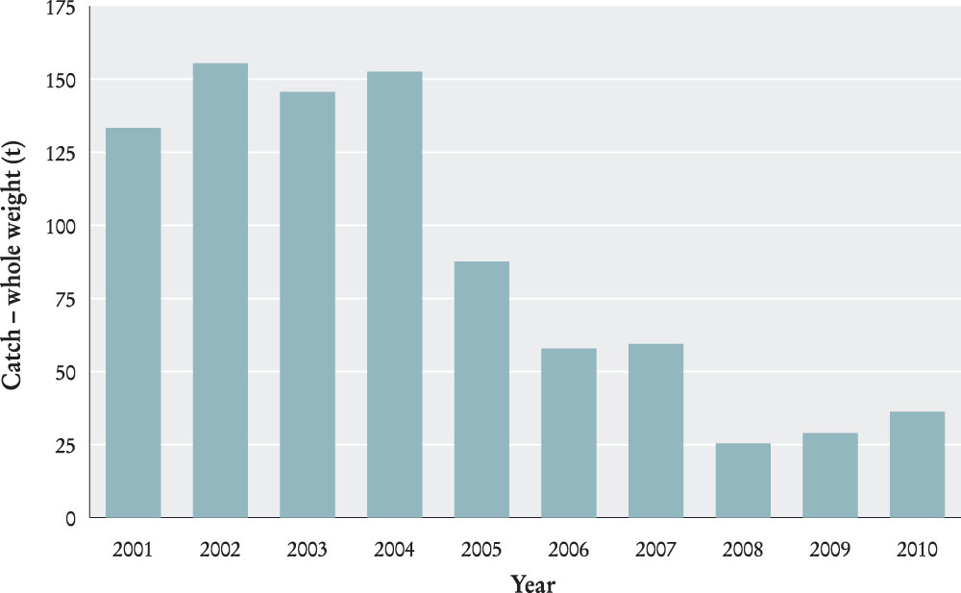
Figure 13 Catches of coral trout (Plectropomus sp.) in the Torres Strait Finfish (Reef Line) Fishery (Source: Logbook data 2001-2010, docket book data 2004-2010 and other records).

Strategic assessment—update
The fishery was strategically assessed under the EPBC Act during 2008 and was formally accredited as a WTO in November 2008. SEWPaC also provided a number of accreditation recommendations to improve the sustainability of the fishery. The export accreditation is valid until 25 November 2011 at which time the fishery will be re-assessed.

CRAB

Description of the fishery
The Torres Strait Crab Fishery (TSCF) primarily targets mud crab (Scylla spp.), however smaller quantities of blue swimmer crab (Portunus pelagicus) have been retained in the past. The level of participation in the commercial fishery is low and restricted mainly to Saibai and Boigu where there is a large area of crab habitat.
All fishery participants are Traditional Inhabitants of Australia. Mud crabs are generally captured by hand or using scoop nets.

Management objectives
The objectives for the TSCF have been developed in conjunction with the objectives of the Act and the Treaty. These objectives reflect the status of the fishery following the change in jurisdiction in 1999, from a fishery managed solely under Queensland law to one managed by the Commonwealth. The objectives adopted include:
- to manage the resource to achieve its optimum utilisation
- to maximise opportunities for Traditional Inhabitants of Australia and PNG to participate in the commercial fishery.

Management arrangements
Participation in the TSCF is limited to Traditional Inhabitants. A number of management arrangements apply including:
- a prohibition on the take or possession of female crabs and spanner crabs (Ranina ranina)
- a limit of 50 prescribed crab apparatus per operator
- no vessels greater than 14 m in length
- a minimum carapace length of 15 cm for mud crabs.

Condition of the fishery
At January 2011 there were 64 TIB fishers licensed to operate in the TSCF however no commercial activity was recorded in 2010.
An unknown quantity of mud crab was taken in the course of traditional fishing. The status of crab stocks in the TSPZ is uncertain.

Strategic assessment—update
The TSCF has not been strategically assessed under the EPBC Act. It may in the future, depending on activity in the fishery.

TROCHUS

Description of the fishery
The Torres Strait Trochus Fishery (TSTF), targeting trochus (Trochus niloticus), is a small, single-species commercial and traditional fishery reserved for Traditional Inhabitants of Australia. The fishery has been an important source of income for some Traditional Inhabitants, especially in the central and eastern Torres Strait communities; particularly between 1920 and 1950 and more recently during the 1980s. The fishery is characterised, like trochus fisheries elsewhere, by fluctuating fishing activity when the price paid for shell is economically attractive. The level of participation in the fishery has continued to decrease since 2006 in response to a fall in the price paid for the shell.
Trochus is usually taken by free diving with fishers generally operating from dinghies with a crew of two or three. Reef top collection of trochus is also possible at low tide. In December 2005 the use of underwater breathing apparatus was formally banned.

Management objectives
The management objectives for the TSTF during 2010–11 were to:
- manage the resource to achieve its optimum utilisation
- maximise opportunities for Traditional Inhabitants of Australia
- encourage Traditional Inhabitants to participate in the TSTF.

Management arrangements
Participation in the TSTF is limited to Traditional Inhabitants of Australia.
The taking of trochus is restricted to hand collection or by hand-held non-mechanical implements. The use of underwater breathing apparatus is not permitted. A minimum size limit of 80 mm and maximum size limit of 125 mm applies to all commercial fishing and there is a total TAC of 150 tonnes for the TSPZ.

Condition of the fishery
As at January 2011 there were 68 TIB licenses with a trochus endorsement. Because of its small size, low value and lack of fishery data, a stock assessment of the fishery has not been possible.
The reported catch of trochus in 2010 was 0.65 tonne (Figure 14). Trochus meat is often consumed by fishers’ families or other members of the community and there is interest to find a viable market for trochus shells as well as trochus meat. In 2010, ABARES classified trochus in the TSPZ as not subject to overfishing, but acknowledged uncertainty about the biomass of the stock (Woodhams et al., 2011).
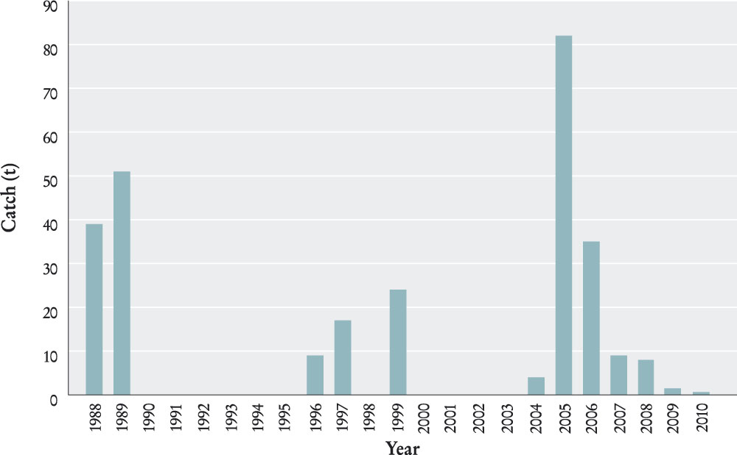
Figure 14 Trochus catch between 1988 and 2010. Data not available between 1990-1995 and 2000–2003 inclusive (Source: AFMA Docket book database.)
Results from a 2009 survey of trochus in eastern Torres Strait indicate trochus stocks are stable or increasing in abundance. However, there is some uncertainty due to the patchy distribution of trochus. Further investigation of this uncertainty is not warranted at this time with the low level of effort in the fishery.

Strategic assessment—update
The TSTF was strategically assessed under the EPBC Act and formally accredited a WTO on 25 November 2008 for continued export approval until 25 November 2011. The WTO declaration is subject to the conditions and recommendations developed by SEWPaC.

BÊCHE-DE-MER (SEA CUCUMBER)

Description of the fishery
The Torres Strait Bêche-de-mer Fishery (TSBDMF) is an important commercial fishery to some Torres Strait Traditional Inhabitants. The fishery dates back to at least the 19th century or earlier. During its history there have been several “booms and busts” which have been a feature of these fisheries in most places.
Fishing for bêche-de-mer in the Torres Strait is mainly by free diving from dinghies crewed by two or three fishers or by hand collection along reefs at low tide. Once collected, the animal is gutted, graded, cleaned, boiled, smoked and dried. This is a labour-intensive process usually carried out on processing vessels or at shore-based facilities.

Management objectives
The management objectives for the TSBDMF in 2010–11, included in the Torres Strait Bêche-de-mer Fishery Statement of Management Arrangements, were to:
- ensure the sustainable use of all sea cucumber in Torres Strait
- ensure that utilisation of the sea cucumber resources is for the direct benefit of the Australian Traditional Inhabitants of the Torres Strait
- ensure increased involvement in the management and control of all aspects of the fishery by the Australian Traditional Inhabitants of the Torres Strait
- promote a cooperative approach to management with PNG
- ensure the recovery of the sandfish stock on Warrior Reef, in consultation with industry and traditional fishers, by adopting a precautionary approach when setting catch levels in the early years of rebuilding the fishery.

Management arrangements
Participation in the TSBDMF is limited to Traditional Inhabitants only, with the exception of one long-term non-Traditional Inhabitant who was active in the fishery prior to the introduction of licence limitations in this fishery in late 1995.
Bêche-de-mer can only be taken by hand collection or hand-held non-mechanical implements and the use of hookah or scuba diving gear is not permitted.
A bag limit of three per person or six per boat applies to traditional fishing. A competitive TAC (measured in wet weight gutted) and size limits apply to commercial fishing. Three species currently have a zero TAC and are closed to fishing (Table 3). Boat sizes are also limited to a maximum of seven metres in length.

Table 3 Catch limits (TACs) and size limits of commercially harvested species in the TSBDMF. (Source: Fisheries Management Notice No. 64).
Commercial Value | Common name | Scientific name | TAC (Tonnes) | Size Limits (mm)
High | Sandfish  White teatfish  Black teatfish* | Holothuria scabra  Holothuria fuscogilva  Holothuria whitmaei | 0  15  0 | 180  320  250
Medium | Surf redfish  Deepwater redfish  Blackfish  Prickly redfish | Actinopyga mauritiana  Actinopyga echinites  Actinopyga miliaris  Thelenota ananas | 0  Combined TAC  Combined TAC  20 | 220  120  220  300
Low | Stonefish  Lollyfish  Elephant’s trunkfish  Greenfish  Curryfish**  Amberfish  Brown sandfish  Leopardfish***  Pinkfish | Actinopyga lecanora  Holothuria atra  Holothuria fuscopunctata  Stichopus chloronotus  Stichopus hermanni  Thelenota anax  Bohadschia vitiensis  Bohadschia argus  Holothuria edulis | Combined TAC  Combined TAC  Combined TAC  Combined TAC  Combined TAC  Combined TAC  Combined TAC  Combined TAC  Combined TAC | NA  150  240  NA  270  NA  NA  NA  NA
* previously H. nobilis; ** previously S.variegatus; ***also known as tigerfish

Condition of the fishery
Bêche-de-mer is especially susceptible to overfishing because they are large, easily seen, easily collected, and do not require sophisticated fishing techniques. During the 1990s, the fishery was based primarily on sandfish (Holothuria scabra), a high-value species occurring in relatively shallow waters, and as a result vulnerable to over-harvesting. Following concerns of serious resource depletion and overexploitation of sandfish stocks on Warrior Reef, six fishery-independent surveys were commissioned to assess the level of reduction in sandfish abundance in 1995–96, 1998, 2000, 2002, 2004 and 2005. Following the 1998 survey the harvest of Sandfish was prohibited as results indicated the remaining stock on Warrior Reef was approximately 80 per cent less than three years earlier. Subsequent surveys did not record any substantial increase in stock. The 2004 survey indicated a further decline in stock abundance that may have been the result of illegal harvesting.
Following the closure of harvest for sandfish, fishing switched to other high value species focused on surf redfish (Actinopyga mauritiana), black teatfish (H. whitmaei), white teatfish
(H. fuscogilva) and some lower-value species. The 2002 CSIRO survey on the eastern reefs of Torres Strait indicated that the black teatfish and surf redfish had experienced significant declines in abundance, and as a result the PZJA set zero TACs for surf redfish and black teatfish, effectively closing the fishery for these two species. Another survey in 2005 showed no increase in abundance and the TAC of these two species remains set at zero.
The 2005 survey of the eastern Torres Strait reefs also resulted in the PZJA agreeing to set far more precautionary TACs for the white teatfish and prickly redfish (Thelenota ananus) of 15 and 20 tonnes respectively in 2006. Setting single species quotas for both species was recommended by the then Minister for the Environment and Heritage.
Surveys in 2006 showed that the three species currently closed to fishing, sandfish, black teatfish and surf redfish had not recovered from their low densities observed in previous surveys. Although there is zero recorded harvest of these species in docket books for 2008, the extent of illegal, unregulated or unreported harvest of these stocks is unknown and so the stocks are classified uncertain with regard to overfishing. Of the remaining fished species, prickly redfish and white teatfish showed decreases in average density and/or average size. While the report did not propose any changes to the recommended TACs of these species as catches have remained low since 2002, it led to the recommendation that they should be closely monitored through regular population surveys.
In 2009, CSIRO conducted a stock abundance survey of bêche-de-mer and trochus in eastern Torres Strait, particularly focussing on black teatfish. This survey included training and involving twelve Torres Strait Traditional Inhabitants in survey techniques. The survey results from the sea cucumber baseline abundance survey in the eastern Torres Strait found that black teatfish, currently with a zero TAC, showed signs of recovery with higher numbers and larger individuals being recorded compared to previous surveys. The survey also noted that other bêche-de-mer species were showing stable or increasing abundance. The researchers recommended an increase in TAC for black teatfish from zero to 25 tonnes. This recommendation is being considered by the Hand Collectables WG in conjunction with community based harvest strategies.
In 2010, a survey of sandfish at Warrior Reef and surrounding area was conducted and provisional results indicate some signs of stock recovery, although further analysis of these results is pending. The survey also identified potential uncertainty in the estimates of stock abundance due to difficulties of the survey techniques recording sandfish that are burrowed.
The status of species in the TSBDMF varies. Table 4 on page 43 provides a summary of species statuses from the 2010 ABARES Fishery Status Report (Woodhams et al., 2011).
Illegal fishing incursions by PNG nationals at Warrior Reef have been reduced since the three year closure of PNG’s Bêche-de-mer fishery in October 2009. The closure was extended for a further three years in October 2012. Australia will continue to conduct surveillance of Warrior Reef and maintain a response capability in the area through AFMA’s Foreign Compliance team. Coastwatch flights also sweep the area daily.
Table 4 Summary of species status within the Torres Strait BDM fishery (summarised from Woodhams et al., 2011)
Species | Comments
Black teatfish (Holothuria whitmaei) | No catch reported in 2010. The most recent survey estimates (2009) indicate a recovered stock.
Prickly redfish (Thelenota ananas) | Catch less than TAC. Relatively stable densities through recent history of fishery.
Sandfish  (Holothuria scabra) | No catch reported in 2010. Most recent published survey (2010) showed density is still below 1995 density estimate.
Surf redfish  (Actinopyga mauritiana) | No catch reported in 2010. Historical density estimates and historical catch are uncertain due to identification issues.
White teatfish  (Holothuria fuscogilva) | No catch reported in 2010. Relatively stable densities in 1995, 2002 and 2005 surveys, potentially increasing between 2005 and 2009 surveys.
Other sea cucumber species (18 species) | Uncertainty in catch composition and basket nature of stock.
There has been little reported catch from docket book returns since 2005 and low levels of activity in the fishery due to the poor market price for the remaining bêche-de-mer species open to fishing. There was some small commercial catch in the TSBDMF in 2010 (Figure 15) however it cannot be reported for confidentiality reasons.
At 30 June 2010 there were 48 TIB licences with bêche-de-mer entries.
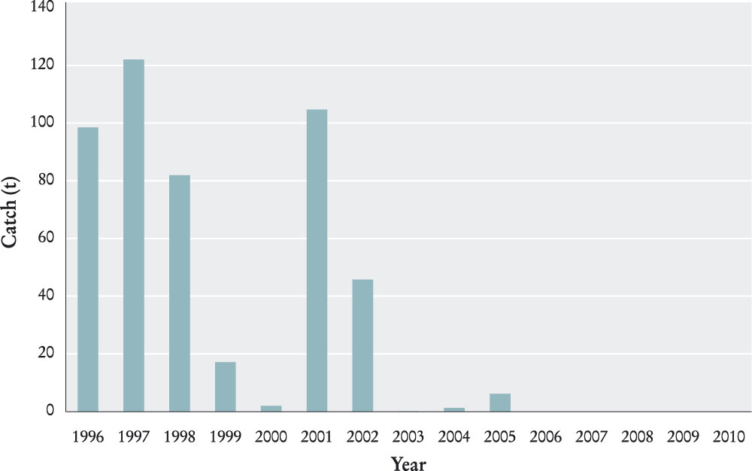
Figure 15 Total Torres Strait bêche-de-mer catch between 1996 and 2010 (Source: Strategic & Export Annual Report, Torres Strait Bêche-de-mer Fishery, AFMA 2010). Note - a limited amount of catch was reported in 2007 and 2010, but cannot be reported because of confidentiality requirements.

Strategic assessment—update
The TSBDMF was strategically assessed under the EPBC Act during 2005 and was formally accredited as a WTO in late June 2005. In June 2008 the fishery was reassessed and was again formally accredited as a WTO for a further three years from 18 June 2008.
The fishery was reassessed under the EPBC Act during the first half of 2011, and on 16 June 2011 was again formally accredited as a WTO for a further three years, until 20 June 2014. The WTO declaration is subject to conditions and recommendations developed by SEWPaC.

6 LICENSING
Fishing boat licences are required for commercial fishing in all PZJA fisheries. Three types of fishing boat licences exist:
- Traditional Inhabitant Fishing Boat Licences (TIB)
- Torres Strait Fishing Boat Licences (TVH)
- Torres Strait Sunset Fishing Boat Licences.
Certain fisheries are restricted to Australian Traditional Inhabitants only, and therefore the entries for these fisheries are only found on TIB licences TIBs must be fully owned and operated by Australian Traditional Inhabitants. Australian Traditional Inhabitants that are eligible for a TIB licence must be one of the following:
- Torres Strait Islanders
- Aboriginal people from five Northern Peninsula Area communities (Bamaga, Injinoo, New Mapoon, Seisia, and Umagico)
- certain former Papua New Guineans who are now Australian citizens
- licensees who are resident in the TSPZ or the outside but near area.
TVH licences can be owned by either Australian Traditional Inhabitants or non-traditional Inhabitant Australians. A Torres Strait Master Fisherman’s Licence is required to operate this type of licensed boat. The Torres Strait Master Fisherman’s Licence must also have fishery entries appropriate to operate the boat.
The numbers of licences issued or renewed by the PZJA during 2010–11 which were current as at 30 June 2011 are provided in Tables 4 to 8 (pages 43–48. Numbers provided for boat licences exclude those held in “No Boat” status.
Under catch sharing arrangements set out in the Treaty, PNG is entitled to 25 per cent of the fishing catch or effort in the Australian area of the TSPZ. The PZJA have been working towards introducing TACs in the TRL, Reef Line, and Spanish Mackerel fisheries and a reallocation of these resources in order to meet the Australian Government’s obligations to PNG, and to redistribute a greater share of the total allowable catches to Australian Traditional Inhabitants.
During 2007–08, the Australian Government negotiated a voluntary surrender of all Reef Line and Spanish Mackerel fishery endorsements within the TVH-licensed sector (the entire licence was surrendered if there were no other endorsements on the licence). The process was finalised on 30 June 2008. Whilst access to both the Reef Line and Spanish Mackerel fisheries is now restricted to Traditional Australians and PNG nationals holding a TIB Licence, non-Traditional Inhabitants can gain temporary access through a ‘quota leasing system’. This process is administered via the issuing of sunset licences.
Sunset Fishing Boat Licences are owned by the TSRA. These are leased to temporarily transfer some of the unused effort in the Reef Line and Spanish Mackerel fisheries to non-Traditional Inhabitants. The intent of this system is to maintain the market for these fisheries by ensuring ongoing supply of product from the TSPZ until a point where the Traditional Inhabitant effort increases to an appropriate level. A Torres Strait Master Fisherman’s Licence is also required to operate this type of licensed boat.

Table 5 Number of Master Fisherman’s licences by combinations of Torres Strait fisheries (current as at 30 June 2011).
Fishery | Licences
Tropical rock lobster | 22
Tropical rock lobster, reef line, Spanish mackerel, and pearl | 5
Tropical rock lobster, reef line, and prawn | 1
Tropical rock lobster, reef line, Spanish mackerel, pearl, and prawn | 6
Tropical rock lobster, and Spanish mackerel | 2
Tropical rock lobster, Spanish mackerel, and pearl | 35
Tropical rock lobster and pearl | 5
Reef Line | 5
Reef line and Spanish mackerel | 4
Reef line, Spanish mackerel, and prawn | 4
Reef line and prawn | 48
Spanish mackerel | 7
Pearl | 3
Prawn | 39
Bêche-de-mer | 5
Total | 191
Table 6 Number of TIB licences in each Torres Strait fishery (current as at 30 June 2011).
Fishery | Licences
Bêche-de-mer | 38
Crab | 65
Tropical rock lobster | 277
Reef line | 119
Spanish mackerel | 132
Pearl shell | 39
Trochus | 63
Table 7 Number of TVH licences in each Torres Strait fishery (current as at 30 June 2011). Numbers provided for boat licences exclude those held in “No Boat” status.
Fishery | Primary | Tenders | Total
Bêche-de-mer | 1 | 2 | 3
Tropical rock lobster | 13 | 33 | 46
Pearl shell | 10 | 17 | 27
Prawn | 41 | 0 | 41
Torres Strait fisheries which are not covered by a Fisheries Management Notice | 3 | 13 | 16
Table 8 Number of Torres Strait Sunset Fishing Boat Licences in each Torres Strait fishery (current as at 30 June 2011). Numbers provided for boat licences exclude those held in “No Boat” status.
Fishery | Primary | Tenders | Total
Reef line | 1 | 4 | 5
Spanish mackerel | 3 | 5 | 8

7 SURVEILLANCE AND ENFORCEMENT

Background
The Queensland Boating and Fisheries Patrol (QBFP) is responsible for the TSPZ Domestic Compliance Program. The purpose is to:
- enforce fisheries legislation in a manner that results in a high level of compliance
- educate and advise both traditional and commercial fishers on the need for fishing laws in manner that results in a high level of voluntary compliance
- undertake duties as required by the PZJA to protect TSPZ resources.
QBFP officers, based on Thursday Island and Cairns delivered the 2010–11 Domestic Compliance Program through at-sea inspections using a number of vessels and community visits.

Vessels
The QBFP has two commercially registered departmental patrol vessels:
- Pelagic, a 6.7 metre rigid hull vessel used to conduct local fisheries and marine safety patrols.
- Sea Jay, a 4.3 metre vessel used to patrol the local port area only and respond to local complaints.
The Pelagic is capable of achieving patrols of the Prince of Wales group of islands and some of the closer island communities.
The QBFP also charters a Queensland Police Service (QPS) vessel to conduct offshore patrols. QPS involvement also addresses a number of workplace, health and safety issues particularly those concerning personal safety.
The QBFP also has a number of other private commercial vessels available to it if required.

Community visits
The QBFP also performs extension services through community visits. These visits are imperative for achieving voluntary compliance. During the reporting period QBFP officers visited sixteen island communities and five communities on the Northern Peninsula.
Community visits are also conducted to gather intelligence which is used to inform and schedule TSPZ patrols.
The visits also enable Community members to discuss issues relating to commercial, traditional and recreational fishing as well as boating safety issues. Issues discovered during community visits include:
- licensing procedures
- unlicensed fishing
- confusion as to the licensing requirements for Traditional Inhabitants who wish to exercise their traditional rights in regards to traditional fishing.

QBFP TSPZ compliance priorities
Key priorities in the TSPZ as determined by the QBFP Compliance Risk Assessment process are set out in Table 9.

Table 9 Key compliance priorities in the TSPZ.
Fishery | Compliance Priorities
Bêche-de-mer | - Unlicensed (PNG nationals taking BDM within TSPZ)  - Take of no take species
Reef Line/ Spanish mackerel | - Unlicensed  - Excess tenders
Pearl shell | - Unlicensed
Prawn | - Vessel Monitoring System  - Bycatch Reduction Device/Turtle Exclusion Device  - Gear restriction  - Shark finning  - Bycatch (TRL)
TRL | - Unlicensed tenders  - Size restriction  - Closures
Turtle and dugong | - Non-Traditional Inhabitant take  - Gear restriction

Program outcomes
The QBFP have recently trialled the QPS vessel as a patrol platform and staff may be teamed alongside police officers when performing field duties. This agreement commenced in March 2010. Previously the District utilised a private charter vessel.
Utilising other Government resources such as Police improves the Districts ability to patrol and enforce fisheries legislation throughout the TSPZ.
Additionally the District has a number of resources that may be used to accommodate a response when the need arises. These platforms can include other Government resources such as the Royal Australian Navy and other private commercial vessels that may be chartered.

Royal Australian Navy
The vessel was not used during the 2010–11 reporting year.

Community visits
Whilst not a key role of QBFP, the District does in addition to inspections within the various fisheries, perform extension services such as community visits. These visits are imperative for achieving voluntary compliance. During 2010–11 the QBFP visited the following island communities:
- Badu Island
- Boigu Island
- Coconut (Poruma) Island
- Darnley(Erub) Island
- Dauan Island
- Horn (Ngurapai) Island
- Mabuiag Island
- Moa Island (Kubin Community)
- Moa Island (St Pauls Community)
- Murray (Mer) Island
- Prince Of Wales (Muralag) Island
- Saibai Island
- Warraber Island
- Thursday Island
- Yam (Iama) Island
- York (Masig) Island.
Community visits are also used to gain intelligence which provides useful information for forecasting TSPZ patrols. These may include trends and hot spots. The visits further allow stakeholders to liaise with officers and access information on issues pertaining to commercial, traditional and recreational fishing as well as boating safety issues.
Issues arising from community visits include:
- licensing procedures
- unlicensed fishing
- confusion about the licensing requirements for Traditional Inhabitants who wish to exercise their traditional rights in regards to traditional fishing.
QBFP continue to commit to educating operators whilst performing field compliance duties.
Patrols have focused on several fisheries, the issues identified during the visits are summarised in Table 10 on page 52.

Table 10 Issues identified for fisheries during community visits.
Fishery | Issues
Bêche-de-mer | - Take of no take species (sandfish, black teatfish, surf redfish)  - Unlicensed fishing.
Pearl Shell | - Nil.
Prawn | - Failure to produce documentation (vessel’s fishing authority, vessel’s fishing and safety manuals including manning certificates)  - Failure to carry safety equipment in accordance with registration requirements  - Awareness of current regulations including those contained within Fisheries Management Notices (FMN).
Reef Line/Spanish mackerel | - Low knowledge of current fishery legislation (take/no take species)  - Failure to carry safety equipment in accordance with registration requirements.
Tropical Rock Lobster | - Failure to hold a Torres Strait Master Fisherman’s Licence  - Failure to complete a variation when replacing tenders  - Failure to comply with conditions of a licence  - Lack of knowledge of relevant licensing conditions;  - Taking/retaining undersized lobster  - Failure to produce documentation (manning certificates)  - Failure to carry safety equipment in accordance with registration requirements.
Dugong / turtle | - Lack of knowledge of the fishery sanctuary  - Non-traditional persons participating in activity  - Reported sale of dugong and turtle products  - Failure to carry safety equipment in accordance with registration requirements.

Overall program outcomes
QBFP achieved a total of 40 TSPZ patrol days from November 2010 to the end of June 2011. Table 11 below identifies the type of vessel used for undertaking patrols.
Table 11 Vessel type used to undertake patrol days.
Vessel | Patrol days
Private charter | 10
Queensland Police vessel | 15
Queensland Police RIB | 1
QBFP vessel Pelagic | 14
Total | 40

8 RESEARCH PROGRAMS
The Torres Strait Scientific Advisory Committee (TSSAC) in 2010–11 continued to assess and prioritise strategic research activities for Torres Strait fisheries.
The Annual Operational Plan for Torres Strait Fisheries was reviewed and amended to reflect changes in fisheries status, tactical research needs and directions.
In addition, a guide to cultural protocols for researchers working in Torres Strait was released to Torres Strait communities for comment. The guide will provide researchers with clear expectations of the TSSAC when research is conducted in the Torres Strait.
In 2010–11 four research projects were funded by AFMA—based on recommendation by the TSSAC (Table 12).
Table 12 Research projects.
Research project | Research provider | Principal  Investigator
Assessing stock recovery using experimental fishing for sandfish on Warrior Reef, Torres Strait. | CSIRO | Ms Nicole Murphy
Characterisation of the traditional subsistence fisheries in the Treaty communities (Torres Strait and Papua New Guinea). | CSIRO | Dr Sara Busilacchi
Assessing benefits and develop protocols for “reef gardens” in the Torres Strait – community based management in action. | CSIRO | Ms Nicole Murphy
2012 TRL Stock Assessment and TAC setting. | CSIRO | Dr Eva Plaganyi-Lloyd
In 2010–11, three Torres Strait research project were completed (Table 13).
Table 13 Research projects completed.
Research project | Research provider | Principal Investigator
Development of Cultural Protocols for Torres Strait | Private consultant | Professor NM Nakata
Refined stock assessment and TAC estimation for the TSTRLF | CSIRO | Dr Eva Plaganyi-Lloyd
Recovery of the Holothuria scabra (sandfish) population on Warrior Reef, Torres Strait | CSIRO | Ms Nicole Murphy

9 FINANCIAL ARRANGEMENTS

Cost sharing
The Commonwealth (represented by AFMA) and the State of Queensland (represented by DEEDI-QPI&F) have joint responsibilities for administering certain PZJA fishery functions (e.g. fisheries management, licensing and compliance). A cost share arrangement (CSA) exists between the two parties, initially signed in January 1986, updated in 1999, and again in 2010. The 1999 CSA specifies amongst other matters, how costs are shared and acquitted during each financial year and how assets are managed.
AFMA and QPI&F jointly reviewed the 1999 CSA during 2009—in response to a 2008 PZJA decision. The review identified that the annual acquittal process placed a significant financial risk upon each agency from the requirement to equally share costs and revenue. It was found there was a high probability that either agency could incur a significant unfunded and unbudgeted liability at the end of each financial year.
A new agreed CSA maintains the existing sharing of PZJA functions but avoids the risk of unbudgeted expenditure. The agreement was ratified in June 2010 by; the CEO of AFMA and the Managing Director of QPI&F. It applied to the 2009-10 financial year onwards.

Capital items
Implementation of the initial capital items program, fully funded by the Commonwealth, began in 1985–86 and was completed in the first half of the financial year 1991–92. Each agency tends to its own capital items. The Commonwealth’s capital items held on 30 June 1999 and still held include:
- a joint fisheries/quarantine administrative centre on Thursday Island
- three residences on Thursday Island for the use of regional fisheries staff.

Research costs
Research costs are not subject to the CSA. The Australian and Queensland governments separately fund fisheries research in the TSPZ in accordance with their respective research programs. Research costs are shown in Table 14.
Table 14 Research costs incurred during 2010–11
Australian Government | Costs
An integrated Management strategy Evaluation for Torres Strait Tropical Rock Lobster population | $150,000
TRL Stock Assessment and TAC Setting | $250,005
Characterisation of the traditional subsistence fisheries in the Treaty communities (Torres Strait and Papua New Guinea). | $30,000
Assessing stock recovery using experimental fishing for sandfish on Warrior Reef, Torres Strait. | $51,259
Assessing benefits and develop protocols for “reef gardens” in the Torres Strait – community based management in action. | $28,788
Total Torres Strait Research | $510,052

Overall expenditure
A percentage of AFMA’s and QPI&F’s fisheries management costs are subject to a cost share arrangement; the TSRA receive all Traditional Inhabitant Boat licence fees collected.
To support fisheries management in the Torres Strait levies and/or licence fees are collected from traditional and non-traditional commercial fishers, AFMA receives a percentage of levies collected in relation to the Torres Strait Prawn Fishery. The rest of the prawn levies and all other licence fees associated with non-traditional commercial fishers went to QPI&F. Additionally rent is collected for office and residential accommodation in buildings held by agencies on Thursday Island.
Costs, and revenue, for managing the PZJA fisheries by AFMA and QPI&F during 2010–11 are outlined in Table 15.
In July 2010, to streamline arrangements, the Australian Government Department of Agriculture, Fisheries and Forestry (DAFF) and AFMA agreed to transfer responsibility for PZJA administrative functions to AFMA. As such, DAFF no longer has a Torres Strait section and does not directly record expenditure against the PZJA. DAFF continues to provide policy and legislative support as needed.
For the 2010–11 financial year the TSRA met its financial obligations associated with the PZJA from its own appropriation funding. The TSRA’s 2010–11 financial statements were audited by the ANAO and included as part of the TSRA’s 2010–11 Annual Report. The TSRA does not report the financial costs associated with PZJA activity separately as the PZJA activity forms part of the TSRA’s day to day normal program activity including, but not limited to; turtle and dugong management, environmental management, and economic development and fisheries projects. In addition to appropriation funding, the TSRA received $94,514 from AFMA and DEEDI as co-funding for the Fisheries Coordinator position and $32,020 from TIB licence fees for capacity building for the Community Fishers Group.

Table 15 2010–11 AFMA – DEEDI cost-sharing details
Description | AFMA | DEEDI | Total
Direct Costs
Salaries & on-costs | $689,546 | $685,523 | $1,375,069
Consultants and contractors | $66,008 | $100,000 | $166,008
Travel & subsistence | $72,468 | $221,000 | $293,468
Tropical rock lobster licence buyback | $1,070,000 |  | $1,070,000
Research contracts | $510,052 |  | $510,052
Other administrative costs | $341,555 | $37,000 | $378,555
Total direct costs | $2,749,629 | $1,043,523 | $3,793,152
Indirect Costs
Logbook program | $13,363 |  | $13,363
Data management | $10,695 |  | $10,695
Observers | $46,408 |  | $46,408
Vehicle lease/operating costs |  | $20,000 | $20,000
Information services (VMS polling) |  | $18,000 | $18,000
Depreciation | $95,432 |  | $95,432
Overheads | $118,716 | $391,262 | $509,978
Total indirect costs | $284,614 | $429,262 | $713,876
Total costs | $3,034,243 | $1,472,785 | $4,507,028
Revenue
Rent and building | $87,053 |  | $87,053
Licenses and levies | $221,609 | $143,725 | $365,334
Total revenue | $308,662 | $143,725 | $452,387
Net expenditure | $2,725,581 | $1,329,060 | $4,054,641

ANNEX A: PZJA OUTCOMES 2010–11
23 NOVEMBER 2010
On the 23 November 2010, the PZJA made the following out of session decisions:
With respect to the TSPF:
1.1 The PZJA AGREED that consistent with the TSPF management plan, harvest strategy and PZJA sustainability reference point, the maximum combined Total Allowable Effort in the Torres Strait prawn fishery should be set at 9,200 days for the 2011, 2012 and 2013 seasons.
With respect to the TSPF levies for the 2010 season:
1.1 The PZJA AGREED:
    - to the setting of levies for the TSPF for the 2011 fishing season at $2895.59 per licence and $21.19 per effort unit;
    - to the proposed Fisheries Levy (Torres Strait Prawn Fishery) Amendment Regulations 2010 (No. 1), Explanatory Memorandum and Explanatory Statement; and
    - to the PZJA Chair presenting the Explanatory Statement, along with the proposed Fisheries Levy (Torres Strait Prawn Fishery) Amendment Regulations 2010 (No. 1) to the Federal Executive Council at their 8 December 2010 or subsequent Executive Council meeting to ensure that licences can be granted for the 2011 fishing season, commencing on 1 March 2011.
1.2 The Protected Zone Joint Authority NOTED:
    - The TSPMAC considered the TSPF levies for the 2011 season at an out-of-session meeting on 3 November 2010;
    - that these levy amounts have been set using both AFMA and QPIF budgets;
    - that the per licence levy has decreased from $4,229.06 in 2010 to $2895.59 in 2011 ($1333.47 decrease) and the per unit levy has decreased from $27.23 in 2010 to $21.19 in 2009 ($6.04 decrease); and
    - that for the 2010-11 financial year, the total levy to be collected from industry is $322,162 comprising a QPIF component of $163,387 and an AFMA component of $158,775. Of the total to be collected, QPIF will retain $163,387 to meet Queensland expenses and provide $158,775 to AFMA to meet AFMA expenses.
27 JANUARY 2011
On the 27 January 2011, the PZJA made the following out of session decision:
With respect to the TSTRLF:
1.1 The PZJA AGREED to reintroduce:
    - the 30% tender reduction for non-Traditional Inhabitant (TVH) fishers; and
    - the seven day moon-tide hookah closure as interim management arrangements in the Torres Strait Tropical Rock Lobster fishery for 2011.
10 MAY 2011
On 10 May 2011, the PZJA made the following out of session decisions:
With respect to the TSTRLF:
1.1 The PZJA AGREED to:
    - Conduct structural adjustment through purchase of non-Indigenous (TVH) licences.
    - Introduce catch quota through a Management Plan.
1.2 The PZJA AGREED to:
    - adopt the proposed Communication Strategy in the event that structural adjustment is announced for the Torres Strait Tropical Rock Lobster fishery.
1.3 The PZJA AGREED to:
    - issue a number of Processor-Carrier (TPC-C) licences to the TSRA to be leased out on a yearly basis. Tender conditions agreed to by the Standing Committee, including those relating to towing of fishing dories and accommodating of crew, will apply to these licences.
1.4 The PZJA NOTED that:
    - if a buy-out in the lobster fishery is agreed to, the PZJA will buy the licences offered for sale and the TSRA agree to negotiate with potential lessees to lease back to the TVH sector for a period of up to ten years with a guarantee that lease conditions will not be restricted by additional conditions such as area closures, without the full agreement of the parties to the lease.
1.5 The PZJA NOTED that:
    - recommendations on leasing arrangements are based on the following key points:
i. Purchased non-Indigenous licences will be surrendered on the contract date or other date agreed to by the signing parties.
ii. The interim management arrangements will be removed following the announcement of a structural adjustment package.

ANNEX B: PZJA ADVISORY COMMITTEE AND TORRES STRAIT CONSULTATIVE STRUCTURE: MEMBERSHIP AND MEETING FREQUENCY

Protected Zone Joint Authority (PZJA)
- The Hon. Tony Burke, MP, former Commonwealth Minister for Agriculture, Fisheries and Forestry (July 2010 to September 2010)
- The Hon. Joe Ludwig, MP, Commonwealth Minister for Agriculture, Fisheries and Forestry (September 2010 to June 2011)
- The Hon. Tim Mulherin, MP, former Queensland Minister for Primary Industries and Fisheries (July 2010 to February 2011)
- The Hon. Craig Wallace, MP, Queensland Minister for Main Roads, Fisheries and Marine Infrastructure (February 2011 to June 2011)
- Mr John T. Kris, Chair of the Torres Strait Regional Authority.

Membership of Torres Strait consultative bodies
Protected Zone Joint Authority Standing Committee:
REPRESENTATION* | MEMBER
AFMA (Chair) | Chief Executive Officer
DEEDI (QPI&F) | Deputy Director General Fisheries
TSRA | General Manager
DAFF | General Manager Fisheries
* AFMA took over the roles of PZJA Secretariat, Standing Committee Chair and Standing Committee Secretariat during the 2010–11 financial year. Prior to 2010–11. The Australian Government’s DAFF held the Chair and Secretariat roles. DAFF remains involved with the PZJA and Standing Committee and continues to lead related Government policy development.
Torres Strait Fisheries Management Advisory Committee (TSFMAC):
REPRESENTATION | MEMBER
Chair | Mr John Pollock
Executive Officer | AFMA
CFG – Badu Island | Mr Maluwap Nona
CFG – Bamaga | Mr Clifford Waisu
CFG – Boigu Island | Mr Dimas Toby
CFG – Coconut (Poruma) Island | Mr Francis Pearson
CFG – Darnley (Erub) Island | Mr Leslie Pitt
CFG – Dauan Island | Mr Thomas Mooka
CFG – Hammond Island | VACANT – TBD
CFG – Horn (Ngurapai) Island | Mr Pearson Wigness
CFG – Injinoo | Mr Robert Bagie
CFG – Mabuiag Island | Mr Allan Repu
CFG – Moa Island (St Pauls Community) | Mr John Wigness
CFG – Moa Island (Kubin Community) | VACANT – TBD
CFG – Murray (Mer) Island | Mr Dennis Passi
CFG – New Mapoon | Mr Trevor Lifu
CFG – Prince of Wales (Muralag) Island | Mr Yen Loban
CFG – Saibai Island | Mr Jerry Babia
CFG – Seisia | Mr Harold Townsend
CFG – Stephen (Ugar) Island | Mr William Stephen
CFG – Thursday (Waiben) Island (Port Kennedy) | Mr Graham Hirakawa
CFG – Umagico | Mr Connie Young
CFG – Warraber Island | Mr Nathan Pearson
CFG – Yam (Iama) Island | Mr Charles David
CFG – Yorke (Masig) Island | Mr Gavin Mosby
Fish Receiver representative | Mr Daniel Takai
Tropical Rock Lobster – non-Traditional Inhabitant | Dr Ray Moore
Tropical Rock Lobster – non-Traditional Inhabitant | Mr Brett Arlidge
Finfish (Reef Line) – non-Traditional Inhabitant | VACANT – TBD
Finfish (Spanish mackerel) – non-Traditional Inhabitant | VACANT – TBD
Scientific Member (TSSAC Chair) | Mr Ian Cartwright
TSRA | TSRA Fisheries Coordinator
DEEDI* | Manager (Fisheries Resources)
DEEDI | Senior Fisheries Management Officer
AFMA | Senior Manager (TS Fisheries)
AFMA | Torres Strait Fisheries Manager (TI)
Torres Strait Prawn Management Advisory Committee (TSPMAC):
REPRESENTATION | MEMBER
Chair | Mr Jim Gillespie
Executive Officer | AFMA
CFG – Coconut (Poruma) Island | Mr Francis Pearson
CFG – Yam (Iama) Island | Mr Charles David
CFG – Yorke (Masig) Island | Mr Gavin Mosby
Prawn, non-Traditional Inhabitant | Ms Kylie Paulsen
Prawn, non-Traditional Inhabitant | Mr Marshall Betzel
Prawn, non-Traditional Inhabitant | Mr Chris Bourke
Prawn, non-Traditional Inhabitant | Mr Ron Earle
Prawn, non-Traditional Inhabitant | VACANT – TBD
TSRA | Fisheries Policy Officer
AFMA | Senior Manager (TS Fisheries)
AFMA | Torres Strait Fisheries Manager (TI)
DEEDI | Scientific Member
DEEDI | Manager (Fisheries Resources)
DEEDI | Senior Fisheries Management Officer
QBFP | Compliance Member
Papua New Guinea* | NFA Fisheries Officer
Papua New Guinea* | NFA Fisheries Officer
DFAT* | Treaty Liaison Officer
DAFF* | Policy Officer
SEWPaC* | Environment Officer
ABARES* | Economist
* Denotes permanent observer status
Torres Strait Scientific Advisory Committee (TSSAC):
REPRESENTATION | MEMBER
Chair | Mr Ian Cartwright
Executive Officer | AFMA
Scientific Member – Social/Economic Scientist | Ms Sevaly Sen
Scientific Member | Dr Michael O’Neill
Scientific Member | Dr Roland Pitcher
Scientific Member | Dr Stephen Newman
Industry Member | Mr Tony Vass
Traditional Inhabitant Representative | Mr Gavin Mosby (proxy)
AFMA Member | Dr Annabel Jones
DEEDI Member | Senior Fisheries Management Officer
TSRA Fisheries Officer* | TSRA Fisheries Coordinator
PNG NFA Representative | PNG
* Denotes permanent observer status .
Torres Strait Finfish Working Group (TSFFWG):
REPRESENTATION | MEMBER
Chair | VACANT – TBD
Executive Officer | AFMA
CFG – Coconut (Poruma) Island | Mr Francis Pearson
CFG – Darnley (Erub) Island | Mr Leslie Pitt
CFG – Murray (Mer) Island | Mr James Bon
CFG – Stephens (Ugar) Island | Mr William Stephen
CFG – Yorke (Masig) Island | Mr Gavin Mosby
CFG – Warraber Island | Mr Nathan Pearson
Finfish (Reef Line) – non-Traditional Inhabitant | VACANT – TBD
Finfish (Spanish mackerel) – non-Traditional Inhabitant | VACANT – TBD
Finfish – non-Traditional Inhabitant | President of QSIA
Scientific Member | VACANT – TBD
TSRA Fisheries Officer | TSRA Fisheries Coordinator
AFMA | TS Fisheries Manager (TI)
DEEDI | Senior Fisheries Management Officer
QBFP (Compliance) | District Officer
Torres Strait Tropical Rock Lobster Working Group (TSTRLWG):
REPRESENTATION | MEMBER
Chair | VACANT – TBD
Executive Officer | AFMA
CFG – Badu Island | Mr Maluwap Nona
CFG – Mabuiag Island | Mr Allan Repu
CFG – Prince of Wales (Muralag) Islands | Mr Yen Loban
CFG – Thursday (Waiben) Island (Port Kennedy) | Mr Graham Hirakawa
CFG – Yam (Iama) Island | Mr Charles David
CFG – Yorke (Masig) Island | Mr Gavin Mosby
Tropical Rock Lobster – non-Traditional Inhabitant | Dr Ray Moore
Tropical Rock Lobster – non-Traditional Inhabitant | Mr Phillip Hughes
Tropical Rock Lobster – non-Traditional Inhabitant | Mr Brett Arlidge
DEEDI | Senior Fisheries Management Officer
AFMA | Torres Strait Fisheries Manager (TI)
TSRA | Fisheries Coordinator & Policy Officer
Scientific Member | CSIRO
QBFP (Compliance) | District Officer
Torres Strait Hand Collectables Working Group (TSHCWG):
REPRESENTATION | MEMBER
Chair | Mr. Kenny Bedford (Interim)
Executive Officer | AFMA
CFG – Badu Island | Mr Maluwap Nona
CFG – Darnley (Erub) Island | Mr Leslie Pitt
CFG – Murray (Mer) Island | Mr Dennis Passi
CFG – Warraber island | Mr Nathan Pearson
CFG – Yam (Iama) Island | Mr Charles David
CFG – Yorke (Masig) Island | Mr Gavin Mosby
TVH Industry Member | Mr Nyall Ledger
Industry Member | Mr Grant Leeworthy (Tasmanian Seafoods)
Scientific Member | CSIRO
TSRA | Fisheries Coordinator
AFMA | TS Fisheries Manager (TI)
DEEDI | Senior Fisheries Management Officer
Torres Strait Tropical Rock Lobster Resource Advisory Group (TSTRLRAG):
REPRESENTATION | MEMBER
Chair | Mr John Pollock
Executive Officer | AFMA
Queensland Industry | Mr Brett Arlidge
DEEDI Scientist | Senior Fisheries Biologist
Torres Strait Fishery (PNG) | NFA Manager PNG-Torres Strait
Torres Strait Industry (PNG Indigenous rep) | Mr Meremi Maina
Torres Strait Industry (Australian Indigenous rep) | Mr Graham Hirakawa
Torres Strait Industry (Australian TVH rep) | VACANT – TBD
Scientific Member | CSIRO
Independent Fisheries Scientist | Mr Nokome Bentley
Bureau of Rural Sciences | Fisheries Scientist
TSRA | Fisheries Coordinator
AFMA | TS Fisheries Manager (TI)
DEEDI | Senior Fisheries Management Officer
GBRMPA* | Senior Project Manager
PNG* | NFA Fisheries Officer
* Denotes Permanent Observer Status

Meetings
Protected Zone Joint Authority
- No meeting
Torres Strait Fisheries Management Advisory Committee
- Out of Session Meeting: 23 November 2010
Torres Strait Scientific Advisory Committee
- Meeting No. 53: 28 October 2010
- Meeting No. 54: 17 February 2011
- Meeting No. 55: 29 June 2011 (Teleconference)
Torres Strait Prawn Management Advisory Committee
- Meeting No. 10: 30 June – 1 July 2010
- Out of Session Meeting: 3 November 2010
- Meeting No. 11: 24 November 2010
- Meeting No. 12: 1 – 2 June 2011
Torres Strait Finfish Working Group
- No meeting
Torres Strait Tropical Rock Lobster Working Group
- No meeting
Torres Strait Hand Collectables Working Group
- Meeting No. 4: 27–28 July 2010
Torres Strait Tropical Rock Lobster Resource Assessment Group
- Meeting No. 9: 5–6 October 2010

ANNEX C: TORRES STRAIT FISHERIES RELATED REPORTS 2010–11
Busilacchi S. (2008) The Subsistence Coral Reef Fish Fishery in the Torres Strait. PhD Thesis, James Cook University. Australia
Cocking, L, Turnbull, C and Jacobsen, I 2011, Torres Strait Prawn Fishery Handbook 2011, Australian Fisheries Management Authority, Canberra, Australia
Flood, M.J., Marton, N. and George, D., 2011, 18 Torres Strait Tropical Rock Lobster Fishery in Woodhams, J., Stobutzki, I., Vieira, S., Curtotti, R. and Begg, G.A. (eds) 2011, Fishery status reports 2010: Status of fish stocks and fisheries managed by the Australian Government, Australian Bureau of Agriculture and Resource Economics and Sciences, Canberra
Marsh, H., Grech, A. and Hagihara, R., 2011, Report to the Australian Marine Mammal Centre and the Torres Strait Regional Authority – Aerial survey of Torres Strait to evaluate the efficacy of an enforced and possibly extended Dugong Sanctuary as one of the tools for managing the dugong fishery, School of Earth and Environmental Sciences, ARC Centre of Excellence for Coral Reef Studies, James Cook University, Australia
Williams, A.J., Begg, G.A., Little, L.R., Currey, L.M., Ballagh, A.C. and Murchie, C.D. (2007). Evaluation of the eastern Torres Strait reef line fishery. Fishing and Fisheries Research Centre Technical Report No. 1.
Woodhams, J, Stobutzki, I, Vieira, S, Curtotti, R & Begg GA (eds) 2011, Fishery status reports 2010: status of fish stocks and fisheries managed by the Australian Government, Australian Bureau of Agriculture and Resource Economics and Sciences, Canberra

ANNEX D: FREEDOM OF INFORMATION ACT AND OCCUPATIONAL HEALTH AND SAFETY ACT STATEMENTS
From 1 May 2011 agencies subject to the Freedom of Information Act 1982 are required to publish information to the public as part of the Information Publication Scheme. This requirement is in Part II of the Act and has replaced the former requirement to publish a section 8 statement in an annual report. An agency plan showing what information is published in accordance with the Information Publication Scheme is accessible from agency websites.
This statement is published in accordance with section 8 of the Freedom of Information Act 1982.
For the 2010–11 financial year the PZJA did not receive any requests for information.
Further information relating for the Freedom of Information Act 1982 and also the Occupational Health and Safety (Commonwealth Employment) Act 1991 with respect to Torres Strait fisheries is contained within annual reports issued by:
- AFMA (fisheries management and research)
- QDPI&F (licencing, compliance and enforcement actions)
- TSRA

In July 2010, responsibility for conducting PZJA administrative functions was transferred to AFMA. As such AFMA took over the roles of PZJA Secretariat, Standing Committee Chair and Standing Committee Secretariat a role that was undertaken by DAFF previously. However, DAFF remains involved with the PZJA and Standing Committee and continues to provide policy and legislative support as needed form the Domestic Policy and Regulation and Governance sections in the Fisheries Branch.
The TRL RAG updated the recommended 2010 TAC to 720t in 2011 due to updated figures for catch in 2009, however the recommended TAC for 2010 remained at 853t.
Collection of catch data from Traditional Inhabitant fishers is voluntary therefore catch records for 2010 are provisional.
Collection of catch data from Traditional Inhabitant fishers is voluntary therefore catch records for 2010 are provisional.
Recorded in Torres Strait Docket books. Reporting of purchases of fish is not compulsory.
The Torres Strait Bêche-de-mer Fishery Statement of Management Arrangements, including these management objectives, were endorsed at PZJA 18 (July 2005) and amended in 2008 to include new TAC’s for white teatfish and prickly redfish.
All species listed as ‘Combined TAC’ have a combined catch limit of 80 tonnes.
In 2004–05, the PZJA implemented a process to remove latent (unused) effort from the Tropical Rock Lobster and Finfish fisheries. This has resulted in a number of licences that no longer have any specific fishery entries. These “non-endorsed” licences still allow the operators to catch fish species that are not subject to specific management arrangements under a Fishery Management Notice (such as squid).
Financial performances of AFMA and QPI&F are reported through their respective annual reports.
Where possible actual expenditure has been recorded, otherwise the budget for the period has been recorded. There may be some slight difference between the two; however, it is unlikely to be significant.

