

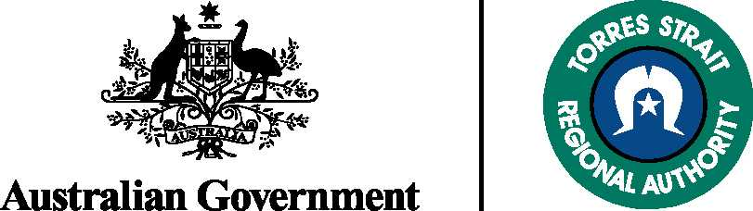


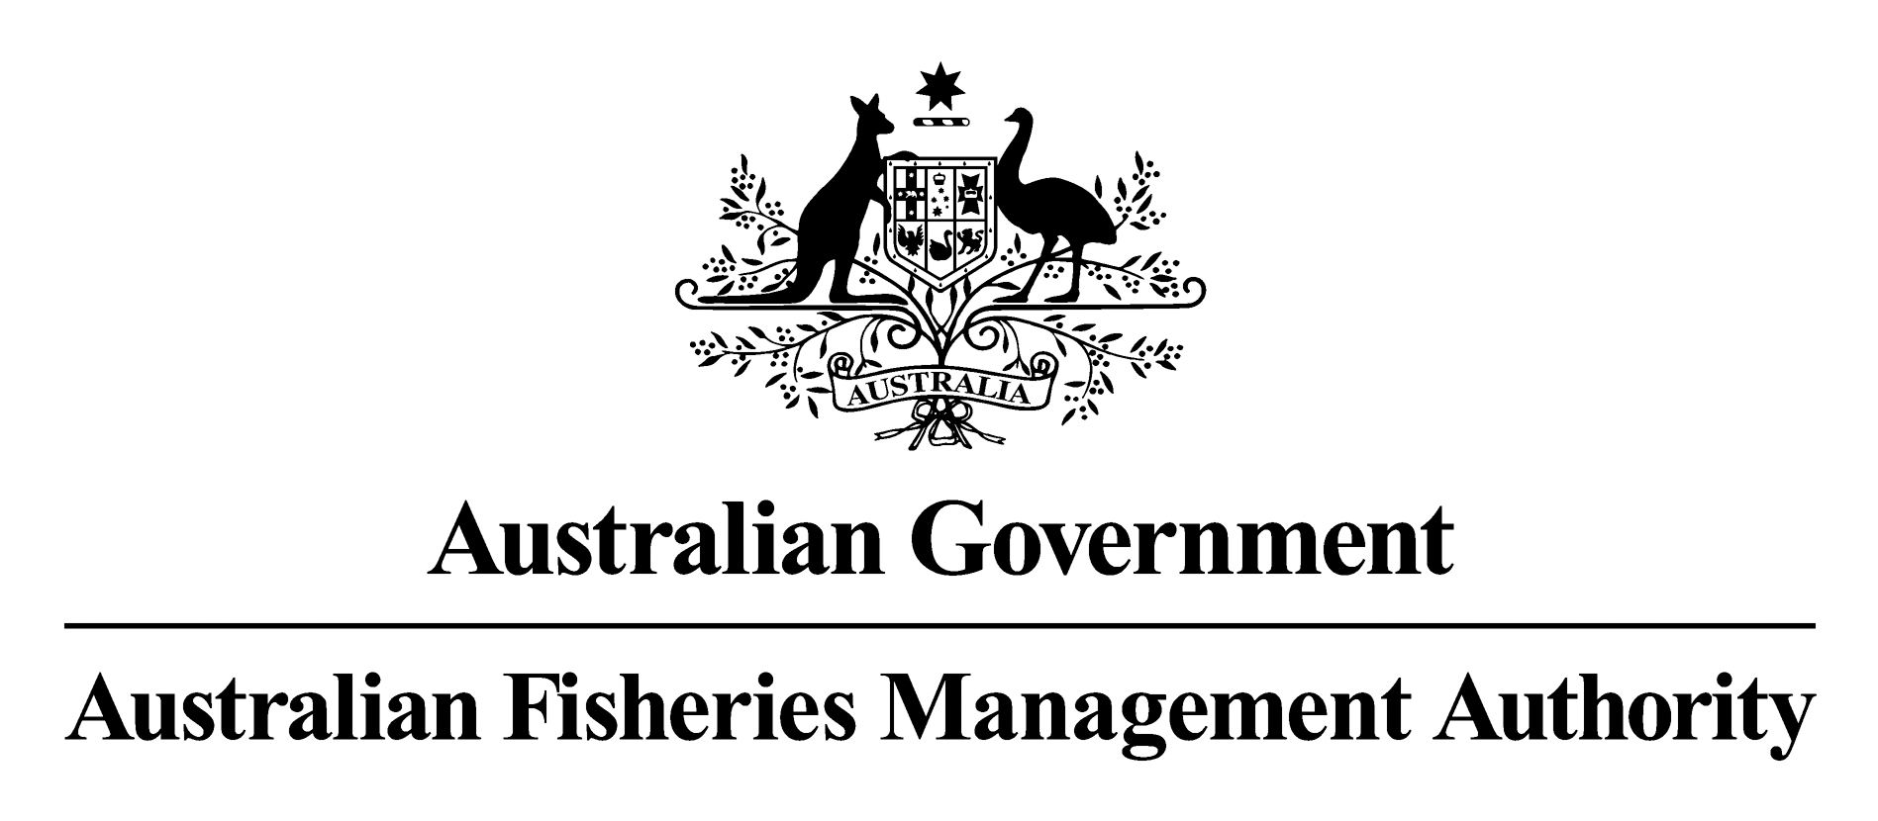

Torres Strait Fisheries Management Advisory Committee
Meeting #12
Thursday Island , 21-22 March 2012

Chair’s summary

A/g Chair: Ms Mary Lack

Should you have further questions, please contact Ms Lisa Cocking, the TSFMAC Executive Officer on (02) 6225 5451.

The 12th meeting of the Torres Strait Fisheries Management Advisory Committee (TSFMAC) was held at Thursday Island on 21-22 March 2012.

MAJOR OUTCOMES

The TSFMAC:

considered the comments received during the draft finfish management plan public comment period and recommended, unamended, the Torres Strait Finfish Fishery Management Plan to the PZJA;

recommended new TACs for some species in the Hand Collectable Fishery;
- noted the severe contraction of the Torres Strait Prawn Fishery (TSPF) and the likely flow on effects of that for other Torres Strait Fisheries, particularly the Rock Lobster and Finfish Fisheries, and recommended that the PZJA continue to investigate, as a matter of urgency, appropriate stimulus measures for the TSPF; and
- considered membership of the Hand Collectable and Finfish Working Groups and the TSFMAC and made recommendations to the PZJA on those memberships.

The key considerations of the meeting are summarised below. A list of attendees and declarations of interest at Attachment A. Meeting Papers, meeting minutes and a full record of decisions will be available on the PZJA website (www.pzja.gov.au).

Hand Collectable Fisheries
Effort in the Beche de mer (BDM) Fishery was very low during 2010, however there was growing interest in the collection of BDM species during the 2011 season, particularly White Teatfish.

The TSFMAC considered the recommendation of the Hand Collectables Working Group to increase the TAC for Black Teatfish, based on outcomes of the recent survey of sea cucumber populations in the eastern Torres Strait. Considering the survey results, the CSIRO recommended a 25 tonne TAC for Black Teatfish. The TSFMAC considered conservative options for opening up Black Teatfish to the fishery and recommended a 15 tonne TAC to be available for one month during the Tropical Rock Lobster (TRL) hookah season, subject to a quota monitoring system developed by Islander fishers, and agreed to by PZJA agencies, being implemented. For the 2012 season, the TSFMAC recommended that the TAC be available in September with the timing to be reassessed prior to the 2013 season.

Changes to the “other species” basket TAC
The TSFMAC discussed removing Blackfish and Deepwater Redfish from the “other species” basket TAC in the BDM Fishery. Under current arrangements, any single species included in the 80 tonne ‘other species’ basket TAC can be fished up to 80 tonnes in any one year if no other species are collected. However, based on survey information that 80 tonnes may not be sustainable for Blackfish and Deepwater Redfish. Consequently, the TSFMAC recommended that these species be removed for the basket TAC and that TACs of 5 and 25 tonnes respectively be introduced for these species.

Update on the CSIRO Sandfish Survey on Warrior Reef
The results of the recent relative abundance Sandfish surveys carried out by the CSIRO on Warrior Reef in February 2010 were discussed. The densities of Sandfish found in the survey indicate some level of recovery of the species, however the stock is still considered overexploited, with levels considered to be less than one third of pre-exploitation levels.

Turtle and Dugong Fisheries
The TSFMAC discussed the development of the community-based management plans for Turtle and Dugong within the Torres Strait, noting that:
- management plans for Badu, Boigu, Iama, Mabuiag, Mer, Erub, and Moa (St Pauls) are currently in place;
- the communities of Saibai, Dauan, Kubin (Moa), Warraber, Poruma, Masig and Ugar commenced implementation of their management plans in 2010;
- the Kaurareg Traditional Owners are still negotiating some of the provisions within their management plan for the inner island areas of the Torres Strait; and
- Indigenous rangers, supported through the TSRA, play an important role in monitoring adherence to the provisions of the management plans.

The TSFMAC also discussed the status of the plans and the implications for enforcement of their provisions, noting that the community-based plans had no legislative backing and only some elements of the plans would be appropriate to be put into legislation, should this be thought necessary.

Recent media reports on traditional harvest of Turtles were also discussed.

Tropical Rock Lobster Fishery
In relation to the TRL Fishery, the TSFMAC discussed and noted:
- that catches in the fishery for the 2010 and 2011 seasons have been high, reflecting the current abundance of the stock;
- the fishery is considered to be underutilised at present, but the Australian fishery is becoming more efficient;
- should a formal quota be considered necessary in the future, funding to support a second survey is likely to be required;
- that the TRL Fishery five year business plan was finalised in late 2011 and is available on the PZJA website;
- the management strategy evaluation (MSE) being undertaken by the CSIRO and, in particular the extension of the MSE approach to encapsulate the social and market dimensions of the TRL Fishery; and
- that the structural adjustment process is currently underway, that the offer period closed on 6 February 2012 and that a Tender Panel has been formed to assess the offers.

Finfish Fishery
The MAC noted that draft Torres Strait Finfish Fishery Management Plan has been in development since 2008 and was released for public comment from 01 February to 16 March 2012. The TSFMAC considered the two comments received, one relating to the need for consultation on decisions taken under the Plan, and the response to these comments from AFMA.

The TSFMAC agreed to recommend the Plan to the PZJA without amendment, noting that the comments were adequately addressed by the provisions of the Plan.

The TSFMAC noted the continuing low level of effort and catch in the Finfish Fishery.

Strategic Assessments and WTO Accreditation for Torres Strait Fisheries
The TSFMAC noted that the Trochus and Finfish fisheries are currently being assessed for re-accreditation as a Wildlife Trade Operation (WTO). The BDM and TRL Fisheries were accredited as WTOs until 20 June 2014 and 23 November 2013 respectively.

Compliance
The TSFMAC discussed the concerns raised by the Finfish Working Group regarding the limitations to compliance with only one compliance officer based in Torres Strait. The TSFMAC noted that there were some reports of non-compliance but Queensland Boating and Fisheries Patrol (QBFP) had not been advised of these issues. QBFP explained that compliance activities and resources were based on risk assessment against a limited compliance budget. It was noted that any increase in compliance activities would require additional budgeting that was not available from Government sources at this time. The TSFMAC noted that only the Torres Strait Prawn Fishery is subject to cost recovery and, therefore, mechanisms to provide additional funds for compliance were not available in most fisheries.

The TSFMAC noted that surveillance of illegal foreign fishing was facilitated by the presence of at least one vessel in Torres Strait at all times and up to three foreign compliance flights per day. The level of both Indonesian and PNG fishing vessel incursions was very low in 2010/2011. Concerns about the potential for foreign illegal fishing for BDM were noted along with the ongoing issue in relation to mud crabs around Saibai.

The MAC noted AFMA’s advice regarding introduction of a vessel identification system for the PNG Treaty villages to allow for identification of treaty endorsed vessels fishing in Australian waters. It was agreed that this system will greatly assist with compliance, maritime rescue operations, border protection and customs surveillance.

Outcomes from other meetings
The TSFMAC had an extended discussion on the current status of the Torres Strait Prawn Fishery (TSPF) and outcomes from the Torres Strait Prawn Management Advisory Committee (TSPMAC) meetings. The TSPF operated at only 16% of the maximum sustainable effort limit in the fishery during the 2011 fishing season.

The MAC noted that the fishery was well managed but was subject to a severe profit squeeze reflecting high fuel prices, low prawn prices, and the remoteness of the fishery. The continual decline in effort in recent years is thought to be indicative of a fishery undergoing economic collapse. The MAC noted that most of the factors affecting the fishery were outside the control of management.

Traditional Inhabitants noted that they gained little benefit from the TSPF and expressed the view that the TSPF had negative impacts on the environment through marine debris, pollution and bycatch which affected important traditional and commercial fisheries.

However, the TSFMAC noted the flow on effects that the reduced effort in the TSPF is likely to have on other fisheries, such as the Rock Lobster Fishery, predominantly through the possible removal of mother-shipping services and that such an outcome would also affect lease prices for quota in the Finfish Fishery. The MAC viewed these flow on effects with concern.

The TSFMAC discussed two proposed research projects aimed at providing the PZJA with necessary information to enable them to make the best decisions on the TSPF. The first, a trial of a few larger boats and larger gear in the TSPF for one fishing season to document the effect on efficiency and economic viability, and the second, a project to collate the perceptions of Traditional Inhabitants on the use of larger boats and gear in the fishery.

The TSFMAC noted the differing views of the members of the TSFMAC on the proposal to trial larger boats in the prawn fishery and recommended that PZJA agencies should continue to investigate appropriate stimulus measures for the TSPF in consultation with stakeholders.

Consultative Group Membership

The TSFMAC agreed to endorse the recommendations of the Hand Collectable and Finfish Working Groups on membership which will be detailed in the full minutes.

The TSFMAC discussed the TSFMAC memberships and agreed to recommend to the PZJA the rollover of the TSFMAC memberships, including the TSFMAC Chair, noting the following changes:
- the current CFG positions be replaced by 10 Indigenous Fisheries Advisory Committee (IFAC) member positions;
- the Chair of the Torres Strait Scientific Advisory Committee be removed as a position on the TSFMAC;
- that the two TVH finfish positions be replaced with one position for a lessee of a sunset licence with a finfish endorsement or any other person with interest in the finfish fishery. This position will be filled through a recruitment round.



Ms Mary Lack
A/g TSFMAC Chairperson

Attachment A
The following members and observers were in attendance at TSFMAC 12.
MEMBERS | Position | Declaration of Interest
Ms Mary Lack | Acting Chair | Consultant
Ms Lisa Cocking | Executive Officer | AFMA
Mr Daniel Takai | Fish processor/buyer | Commercial Buyer
Mr Ned Larry | Traditional Inhabitant Member (elect) | TIB licence Holder
Mr Gavin Mosby | Traditional Inhabitant Member | TIB licence holder and Director of York Island Fishing Group.
Mr Dimas Toby | Traditional Inhabitant Member (elect)
Mr Kiwat Lui | Traditional Inhabitant Member (elect)
Mr Cyril Gabey | Traditional Inhabitant Member (elect) | TIB licence holder
Mr Kenny Bedford | Traditional Inhabitant Member | TIB licence holder
Dr Ian Jacobsen | Fisheries Queensland | DEEDI
Dr Annabel Jones | AFMA | AFMA
Ms Melissa Brown (agenda item 8.2 only) | AFMA | AFMA
Mr Brett Arlidge | Tropical Rock Lobster non-traditional inhabitant member | General Manager M.G Kailis Lobsters
Dr Ray Moore | Tropical Rock Lobster non-traditional inhabitant member | Commercial non-traditional fisherman
Mr Tony Vass | Finfish sunset licence representative (proxy) | No financial interests in the Torres Strait.
Mr Neville Nakata | TSRA | TSRA
OBSERVERS
Mr Damien Miley (agenda item 3 only) | TSRA | TSRA
Mr Steve Hall | TSRA | TSRA
Mr Shane Fava | TSRA | TSRA
Mr Frank Loban (agenda item 3 only) | TSRA | TSRA
Mr Brendan Rayner | AFMA | AFMA
Mr Adam Leatherbarrow | AFMA | AFMA
Dr Kate Brooks | FRDC | FRDC
Mr Matthew Flood | ABARES | ABARES
Mr Lyndon Peddel (half of day one only) | District Officer – Queensland Boating and Fisheries Patrol | QBFP

